GLEN: Phase Two c1994 - c2004
A Resource Paper
Kieran Rose February 2023

- Overview

- Equality Legislation, 1996 to 2000

- Civil Marriage/Civil Partnership/Legal Recognition of Same-Sex Couples

- Poverty: lesbians and gay men : the economic & social effects of discrimination, 1995

‘Lesbian and Gay Visions of Ireland: Towards the 21st Century’ November 1995
- HIV Prevention Strategies and the Gay Community (1996)

- Refugee Act 1996

- Amsterdam Treaty 1997

- Social Partnership

- ‘little short of phenomenal’

- Gay HIV Strategies, 1997

- EHB funded pilot projects

- An Garda Siochana

- Nexus Research Co-operative

- Mainstreaming and Building Partnerships

- HIV Prevention and Gay Youth, 1997

- HIV Prevention in Gay Saunas, 1998

- Waterford Area Partnership and Waterford Regional Youth Services 1999

- Education: Lesbians and Gay Men: Developing Equal Opportunities, 2000

- Implementing Equality for Lesbians, Gays and Bisexuals Equality Authority, 2002

- NESF, Equality Policies for Lesbian, Gay and Bisexual People: Implementation Issues 2003.

- LGB Cycle of Underdevelopment

- Lack of Equality Policy Implementation

- Mental Health: Lesbians and Gay Men - Strategies to Promote the Mental Health of Lesbians and Gay Men" 2004

- making equality a reality in people's everyday lives

- Building Sustainable Change, GLEN Strategic Plan 2006 - 2010

Appendices

GLEN: Phase Two
1994 - 2004

‘The goal of the programme is not about managing our marginalisation, but abolishing it, and therefore making GLEN redundant in the shortest possible time. The Building Sustainable Change programme is ambitious for Ireland and ambitious for our communities. It aims towards a society where being gay is unremarkable; where people can aspire to be openly gay as Taoiseach, CEO, teacher, nurse, construction worker or any occupation they choose. It works towards a society where a young gay or lesbian person can come to terms with their sexuality, confident of support from their family, friends, school and society at large. It seeks to ensure that LGB people can form their own relationships and families and have these recognised on an equal basis with others1’

- Overview

The second phase of GLEN from 1994 to 2005 is an interesting period when significant progress was made but remains mostly undocumented. This is also a period where there were significant problems and barriers such as a lack of State funding for lesbian and gay projects and a lack of representation on official bodies.

The first phase of GLEN could be said to be from its founding in 1988 to achievement of an equality-based gay law reform and sexual orientation included as a protected ground in the Unfair Dismissals Act in 1993. The third phase is from c2006 on when funding from Atlantic Philanthropies enabled it to employ up to eight staff.

Equality legislation was a key goal of the lesbian and gay movement at least since the early 1980s, and was a key priority for GLEN since it was established in 1988. With Labour in a coalition government,The Employment Equality Bill 1996, and the Equal Status Bill 1997 were introduced by Mervyn Taylor, Minister for Equality and Law Reform. We continued to work with the Campaign for Equality to make sure the employment equality and equal status legislation was as positive as possible. Richard Dunphy has an interesting article on GLEN referring to its attempts to improve the legislation for example in relation to the religious ethos exemption. He also refers to the opposition of Chambers Ireland and the Vintners Association to protection on the grounds of sexual orientation under equal status legislation.

Major achievements in Phase Two were the Combat Poverty study and the HIV Prevention one both carried out when GLEN had no staff or office facilities. Eoin Collins did most of the work on the Poverty study and much of the work on the other GLEN and Nexus Research reports. Both of these studies were basic resources for the Equality Authority and NESF reports. Nexus Research continued to facilitate us with the free use of their facilities.

We lobbied the Government successfully for the (re) inclusion of sexual orientation in the Amsterdam Treaty 1997 described by ILGA as ‘a significant milestone for lesbians and gay men in the European Union.’

A particular achievement was the explicit protection on the grounds of sexual orientation in the Refugee Act of 1996 by Joan Burton Minister of State at the Department of Foreign Affairs. This was an international first in terms of the explicit inclusion of sexual orientation in refugee legislation.

We continued to lobby for protections for lesbian and gay couples and this was achieved to an extent in the Domestic Violence Act 1996 and the Powers of Attorney Act 1996. Major progress was achieved Finance Act 2000 so that on the death of one person the surviving partner inheriting their home might not have to sell it to pay CGT.

GLENs emphasis on the need for equality legislation bore fruit with the publication of ‘Implementing Equality for Lesbians, Gays and Bisexuals’ Equality Authority, 2002. And our emphasis on mainstreaming and engagement with the State, the publication by the NESF of ‘Equality Policies for Lesbian, Gay and Bisexual People: Implementation Issues’ 2003. Both of these reports recommended legal recognition of same-sex couples. Eoin Collins was on both working groups, and their reports provided the framework for the GLEN Phase 3 programme.

There were also setbacks, Fergus Ryan writes of the Residential Tenancies Act 2004 which excluded lesbian and gay couples despite this being questioned in the Dail and Seanad and he concludes that this exclusion, ‘was not inadvertent but rather entirely deliberate and intentional’. He also writes of the Civil Registrations Act 2004 (section 2(2) (e)) which stated that ‘For the purposes of this Act there is an impediment to a marriage if—
(e) both parties are of the same sex.’ As far as I can see this exclusion did not appear in the 2003 Bill, was this a result of lobbying from the Right, perhaps alarmed by growing support for legal recognition for same-sex couples in the Equality Authority report and that of the NESF? It is also interesting to note that this was under a FF/PD coalition government, in contrast to progress under Labour in coalition with FF or FG in 1990s. To be fair also Bertie Ahern as Taoiseach delivered a strong speech in favour of progress and equality for LGBT people at the launch of GLENs strategic plan in 2006.

There was also resistance to inclusion of lesbian and gay representatives on State boards, for example on the NESF. There was no publicly out lesbian or gay/sectoral representative Board member of the Equality Authority until 2007. There was no State core funding for lesbian and gay community initiatives under for example the Community Development Programme or local development schemes. This absence of representation and funding was described by GLEN as ‘the Cycle of Underdevelopment’ and was discussed in the NESF report.

There was also a certain resistance or lack of interest from the mainstream and State-funded community development or local development or youth services sectors to engaging with the lesbian and gay community, and the reasons for this are various and well worth investigating, including the negative influence of the Catholic Church; and a certain view amongst some on the left and in the community development sector, that lesbian and gay issues were not relevant to their sector, were not ‘serious’, as if lesbian and gay issues were a matter of ‘lifestyle politics’ (see transcript of interview with Eoin Collins by Michael Barron).

The Waterford Local Area Partnership and Waterford Regional Youth Services are notable exceptions, and GLEN was linked in to them by Nexus Research.

Leo Flynn in 2000 concludes ‘The developments in the Irish legal system in relation to sexual orientation in a decade are little short of phenomenal’ (p17). Regarding the legal recognition of same-sex couples: ‘It is hard to escape the feeling that such recognition will come in the Irish legal system in the medium term’ and ‘Equally, on past record, it is just as likely that the impetus will be domestic’’

Work continued with the Trade Unions, for example the IMPACT policy document ‘Rights of Lesbians and Gay Men’ February was adopted in 1995. ‘A discussion document on the rights of lesbians and gay men was presented to and discussed at the 1993 Equality Conference’ (Paddy Keating). We also worked on updating the 1987 ICTU policy on lesbian, gay and bisexual rights in the workplace published in 2003.

This is a ‘living document’ that will be added to as more material comes to hand.

Key role of individuals or ‘champions’
Pat McLoughlin EHB
Brendan Howlin Minister for Health
Michael McDowell Minister for Justice
Joan Burton (Refugee Act)
Dick Spring
Niall Crowley

Also gatekeepers who said ‘no’

See transcript of interview with Eoin Collins by Michael Barron on www.michaelbarron.org

- Equality Legislation, 1996 to 2000

Equality legislation was a key goal of the lesbian and gay movement at least since the early 1980s, and was a key priority for GLEN since it was established in 1988. GLEN built up support for broad-ranging equality legislation including all groups vulnerable to discrimination working with the Employment Equality Agency (1986), ICTU (1987), ICCL (1990), and the Labour Party on their 1990 Equal Status Bill. GLEN was instrumental in setting up the Campaign for Equality which was an alliance of all groups vulnerable to discrimination including womens groups, people with disabilities, Travellers. The Campaign for Equality was launched in October 1991 in the European Communities offices with speakers including; Monica Barnes, Chair Joint Oireachtas Committee on Women's Rights; Patricia O’Donovan, Assistant Secretary General ICTU; Sylvia Meehan, Chief Executive, Employment Equality Agency; and representatives from GLEN, the Dublin Travellers Education and Development Group; Forum of People with Disabilities; Council for the Status of Women and others.

With Labour in a coalition government,The Employment Equality Bill 1996, and the Equal Status Bill 1997 were introduced by Mervyn Taylor, Minister for Equality and Law Reform and passed in 1997. “They were central to the Rainbow Coalition's raft of anti-discrimination legislation and sought to eliminate discrimination on nine grounds including gender, race, religion, disability and membership of the Travelling community in employment and in the provision of services. They were referred to the Supreme Court (by President Mary Robinson), where both were found to be unconstitutional on three grounds. https://www.irishtimes.com/news/president-has-sole-discretion-to-decide-on-supreme-court-referral-1.287977

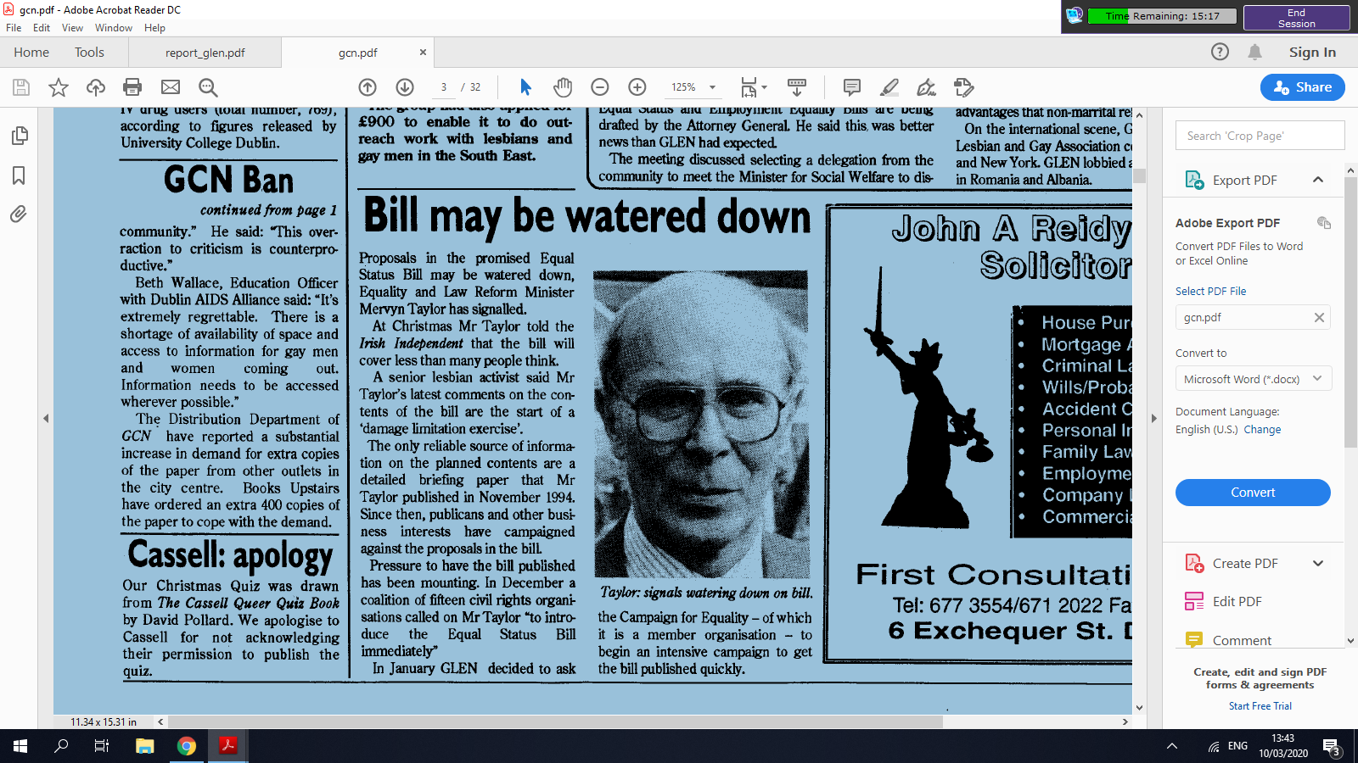
GCN February 1996

Amended equality legislation was subsequently enacted during the following Dáil term, i.e. the Employment Equality Act, 1998 and the Equal Status Act, 2000. The Equality Authority was set up under the Employment Equality Act 1998 and was established in October 1999, and became a key support for the LGBT communities. In November 2014, the Equality Authority was merged with the Irish Human Rights and Equality Commission to form the Irish Human Rights and Equality Commission. The IHREC played a significant role in achieving equal marriage with its detailed policy document of 2015 which stated that;‘The Irish Human Rights and Equality Commission believes that the opening out of civil marriage to two persons, without distinction as to their sex, is a matter of equality and human rights.’ ( https://www.ihrec.ie/documents/ihrec-policy-statement-on-access-to-civil-marriage-febr/
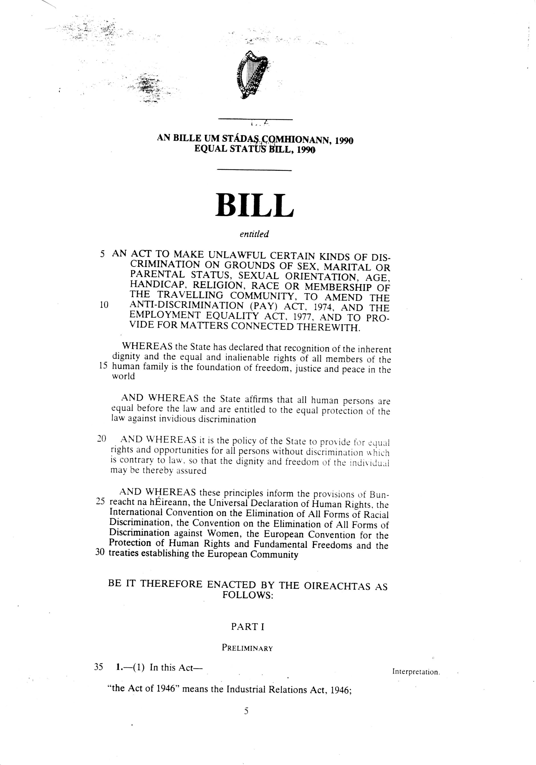
Richard Dunphy has an interesting article (1997) on GLEN referring to its attempts to improve the legislation for example in relation to the religious ethos exemption. He also refers to the opposition of Chambers of Commerce Ireland and the Vintners Association to protection on the grounds of sexual orientation under equal status legislation.

GLEN made a submission to the Constitution Review Group and in its 1996 report it recommend that there should be added to Article 40.1 a section in the following terms:
‘No person shall be unfairly discriminated against, directly or indirectly, on any ground such as sex, race, age, disability, sexual orientation, colour, language, culture, religion, political or other opinion, national, social or ethnic origin, membership of the travelling community, property, birth or other status.’

See separate article; ‘Employment Equality Agency, Sylvia Meehan and the evolution of equality legislation’
https://docs.google.com/document/d/1Byxc3EdJHD9mvnoTgR5WxmSy2hGr3aJXLBovE2dQsAA/edit

The equality legislation with the 9 grounds including sexual orientation provided a very important framework for various NESF reports on equality.

- Civil Marriage/Civil Partnership/Legal Recognition of Same-Sex Couples

In 2005 we made an oral presentation to the Joint Oireachtas Committee on Constitution, in its report it noted GLENs position as follows:

‘Based on the principle of equality of rights, duties and responsibilities, we are asking now that the law on civil marriage be amended so that it is open to any two people, irrespective of gender’

In September and October 2005 GLEN meets Michael McDowell Minister for Justice and Equality making the case for Civil Marriage, the Minister favoured a limited form of domestic partnership. In December 2005 the Minister established the Colley Group and Eoin Collins was one of its members, along with Eilish Barry from the Equality Authority.

The Colley Groups analysis and its equality-based recommendations were pivotal to progress towards full Civil Partnership and Civil Marriage.

In 2005 GLEN was preparing the ‘Building Sustainable Change’ strategy for Atlantic Philanthropies which highlighted civil marriage, with Director of Policy Change Eoin Collins responsible for coordinating this work.

We continued to lobby for protections for lesbian and gay couples and this was achieved to an extent in the Domestic Violence Act 1996 and the Powers of Attorney Act 1996. Major progress was achieved Finance Act 2000 so that on the death of one person the surviving partner inheriting their home might not have to sell it to pay CGT.

There were also setbacks, Fergus Ryan writes of the Residential Tenancies Act 2004 which excluded lesbian and gay couples despite this being questioned in the Dail and Seanad and he concludes that this exclusion, ‘was not inadvertent but rather entirely deliberate and intentional’. He also writes of the Civil Registrations Act 2004 (section 2(2) (e)) which stated that ‘For the purposes of this Act there is an impediment to a marriage if—
(e) both parties are of the same sex.’ As far as I can see this exclusion did not appear in the 2003 Bill, was this a result of lobbying from the Right, perhaps alarmed by growing support for legal recognition for same-sex couples in the Equality Authority report and that of the NESF? It is also interesting to note that this was under a FF/PD coalition government, in contrast to progress under Labour in coalition with FF or FG in 1990s. To be fair also Bertie Ahern as Taoiseach delivered a strong speech in favour of progress and equality for LGBT people at the launch of GLENs strategic plan in 2006.

Interestingly one year after the Civil Registration Act was passed by the Oireachtas, the Colley Group was set up which recommended civil marriage, ot full civil partnership, if marriage was constitutionally vulnerable. Eoin Collins from GLEN was a member of the working group as was Eilis Barry from the Equality Authority.

The Civil Registration Act was to be quoted in 2006 by Justice Dunne in her judgement in the Zappone Gilligan case that they had a Constitutional right to marry: ‘In this jurisdiction, as recently as 2004, s. 2(2)(e) of the Civil Registration Act was enacted. That Act sets out what was previously the common law exclusion of same sex couples from the institution of marriage. Is that not of itself an indication of the prevailing idea and concept in relation to what marriage is and how it should be defined? I think it is.’
https://web.archive.org/web/20150923230051/http://www.bailii.org/ie/cases/IEHC/2006/H404.html

GLEN made a submission ‘Different Families, Equal Families’ in April 1996 to the Government Commission on the Family. We also made a submission to the Constitution Review Group recommending the need for the Constitution to recognise ‘the diversity of personal relationships which now exist in this country’. In its 1996 report the Group recommended recognition of families not based on marriage.

Christopher Robson represented GLEN on the Family Diversity Initiative from 2002 to 2006. This was an informal group with the objective of extending the understanding of family and included groups such as Children's Rights Alliance, One Family etc. Christopher was also on the group that advised Senator David Norris on his civil partnership bill.

Civil Marriage was a key goal of GLEN post-2006 and Eoin Collins was Director of Policy Change with responsibility for coordinating that work, see Appendix for two evaluations of GLENs progress.

According to the NESF report of 2003, the Department of Justice and Equality said at a meeting that; ‘Reform in relation to partnership rights was not covered in the Programme for Government and policy change in this area was unlikely, therefore, in the near future. It was the view of the Department that general reform of the legal and policy codes to reflect the diversity of family forms could require a Constitutional amendment (and that a political commitment would be needed to initiate this). However, a few years later the Minister for Justice and Equality commissioned the Colley Group report which went on to recommend civil marriage as the full equality option and full civil partnership if civil marriage was constitutionally vulnerable. It was a period of rapid change.

- Poverty: lesbians and gay men : the economic & social effects of discrimination
Combat Poverty and GLEN and Nexus 1995

This was ground-breaking and comprehensive research funded by the Combat Poverty Agency and carried out by Nexus Research in association with GLEN. Eoin Collins did the vast bulk of this innovative research. It was an international first in terms of researching the links between sexual orientation, discrimination and poverty and disadvantage.
“The Study has provided an opportunity to hear the voices and experiences of lesbians and gay men who have been caught up in a circle of discrimination, poverty and social exclusion. It shows that discrimination and prejudice result in lesbians and gay men being disadvantaged and excluded from full participation in society. The study should contribute to putting poverty on the agenda of gay and lesbian organisations and putting gay and lesbian issues on the agenda of groups involved in tackling poverty and in promoting greater social equality and social justice."
‘The survey results clearly show that there are significant cumulative and interlocking processes of discrimination operating in key economic and social areas which increase the risk of poverty for lesbians and gay men and further disadvantage those living in poverty. The study also showed how gay people avoid, cope with or resist discrimination. The report made 45 recommendations for a range of areas including family and youth, education and training, employment and unemployment, services, health, harassment and violence and emigration. A key recommendation is that a Task Force composed representatives of government Departments, the gay community and others would be set up to initiate action on the disadvantage identified in the report’ (from Waterford report).
It's findings were used intensively by GLEN and other LGBT groups for many years in advocacy and project proposals. The New Opportunities for Women Programme of the European Union provided significant funding for the Lesbian Education and Awareness (LEA) project, and the poverty report was crucial in making the case for the funding.

It was launched by Minister Proinsias de Rossa in the National Concert Hall, the first time a Government Minister took part in such an event. Proinsias had been a strong supporter for many years, however in a separate meeting he said he would not allow lesbian and gay groups to receive funding under the Community Development Programme. GLEN originally made the research proposal to the Combat Poverty Agency in 1992 but were refused initially.

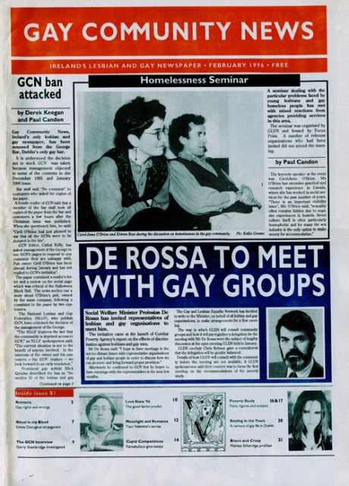
The report obviously captured the imagination of GCN: ‘The centre pages are devoted to the findings of the CPA/GLEN report and it makes for interesting reading, not least as one headline puts it ‘Debunking the rich myth’ of gay people as ‘rich: single or double incomes, no kids’. It paints a much more realistic and sobering picture of a community reflecting the general class and income stratification within the society, ……’

https://documentcloud.adobe.com/link/track?uri=urn%3Aaaid%3Ascds%3AUS%3A881dec3d-305f-41b9-8798-88db00334db2
https://cedarlounge.wordpress.com/2012/03/05/left-archive-gay-community-news-february-1996/

(See transcript of interview with Eoin Collins by Michael Barron)

‘The National Anti-Poverty Strategy (NAPS) report 'Sharing in Progress' (Government of Ireland, 1997: 71-72), which dealt with issues of discrimination and inequality, recorded that evidence has been documented on discrimination leading to poverty for a number of groups and referred to Travellers (Report of the Task Force on the Travelling Community) and lesbians and gay men (Combat Poverty Agency, 1995). It also referred to the "ongoing debate on the extent to which discrimination can increase the risk of poverty for some groups in society". It stated that:
"While homosexuality in itself does not necessarily place one at risk of poverty, the impact, experience and perception of discrimination may limit the full participation of gay men and lesbians in society, and may in some cases place them at risk of poverty".

Reflecting this concern, the Poverty/Equality Proofing Guidelines of NAPS published in 1998 explicitly included sexual orientation. These Guidelines apply to all civil service departments and involve ‘poverty proofing’ in a number of circumstances including the design of policies and preparation of Memoranda to Government on significant policy proposals.’

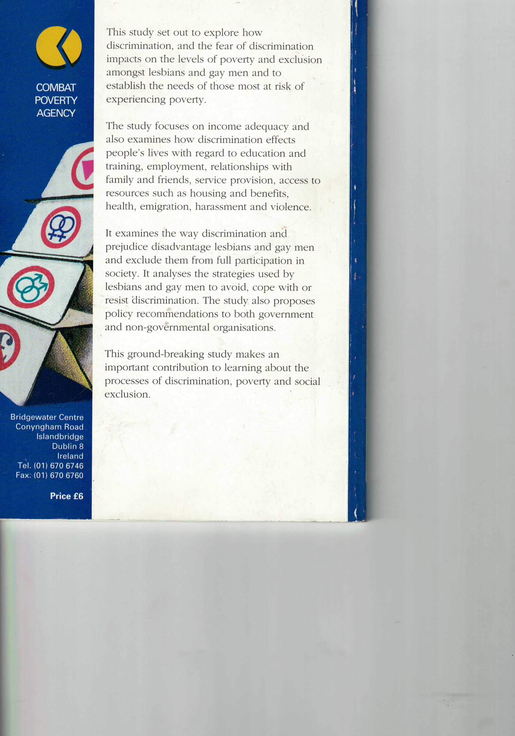
A copy is available on www.LGBTDisregard.ie
And in the National Library of Ireland
See NLI website, Catalog Record:
Link: http://catalogue.nli.ie/Record/vtls000025044

GLEN avoided a 'victimhood' approach, the Poverty study also looked at the strategies used by lesbians and gay men to avoid, cope with or resist discrimination.

The Combat Poverty report identified a significant problem of homelessness and in December 1995 GLEN and Focus Point organised a meeting on homelessness and lesbian and gay issues at which Carol-Anne O’Brien spoke.

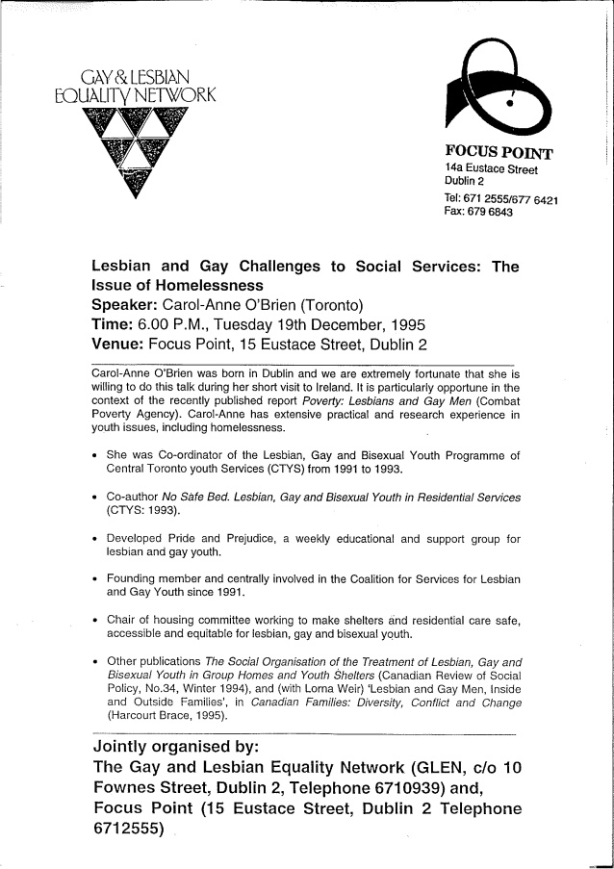

The Combat Poverty Agency magazine ‘Poverty Today’ provided much-needed access to that sector.
See for example; ‘Lifting the Lid on Poverty and Discriminatiton’ by Eoin Collins, Issue 30 December 1996/January 1996.
And ‘Cooperation Key to HIV Prevention’ by Kieran Rose in ‘Poverty Today’, magazine of the Combat Poverty Agency, 1998

‘Lesbian and Gay Visions of Ireland: Towards the 21st Century’ November 1995
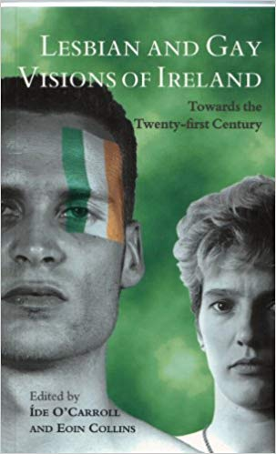

‘Ireland is at a critical stage in its socio-political history, not least because of the encouraging prospect of an end to the war in the North, but also because of the improved position of lesbians and gays …….’ (from blurb) … referring to the equality-based gay law reform, the inclusion of sexual orientation in the Unfair Dismissals Act, ILGOs fight to march in New York, and President Robinsons welcome for lesbians and gays into the Aras.

‘Here a range of voices of those closely involved in the process of change for lesbians and gays in Ireland engage with the shifts in Irish society and politics. Each writer reflects on their work in the community and envisions what the future holds for lesbian and gay citizens in the Republic.’ The articles give a very good overview of the state of play in Ireland at the time. See article by Christopher Robson on GLENs equality campaign, and William O’Connor on HIV/AIDS, and introduction by Eoin Collins
by Ide O'Carroll (Author), Eoin Collins (Author).
Launched in Aras an Uachtaran by President Mary Robinson, and in New York

- HIV Prevention Strategies and the Gay Community 1996
A detailed research report done by GLEN and Nexus Research Co-op with Eoin Collins making a major contribution. Funded by the Dept of Health, a breakthrough following gay law reform, a political decision by then Minister for Health Brendan Howlin and his political advisors, Health officials were not too happy I recall.

The report led to funding for Gay HIV Strategies and other community initiatives such as the Sauna Project. 100 pages, very good historical information on Ireland and internationally. Launched by Minister for State in the Department of Health, Brian O’Shea. There was also a reception in Aras an Uachtaran hosted by President Mary Robinson. An aspect of the unwritten history of the role of Nexus Research and Eoin Collins in their vital support for LGBT progress in Ireland. Dr Noel Browne's moving talk at the AIDS Memorial Service in St Patrick's Cathedral in May 1995 is included in an annexe. https://www.slideshare.net/kieranrose/dr-noel-browne-talk-at-aids-memorial-service-in-st-patricks-cathedral-dublin-may-21st-1995

‘This is the report of Phase One of an action research project to develop a renewed and integrated HIV prevention strategy for gay men. The objective is to radically reduce the number of new HIV infections so that it approaches zero. The report was commissioned and funded by the Department of Health, co-ordinated by the Gay and Lesbian Equality Network and carried out by Nexus Research Co-operative. The project is based on the principle that gay community development and measures to promote the self-esteem of gay men are essential to effective HIV prevention work. The research focused on examining the capacity and needs of gay community organisations to carry out such health promotion work. The report also includes the findings of a survey of the statutory sector and other voluntary AIDS groups as well as
a survey of relevant Irish and international literature. The report recommends that there should be a partnership between the gay community and the statutory sector.’ (from blurb)

Eoin Collins researched and wrote much of this report

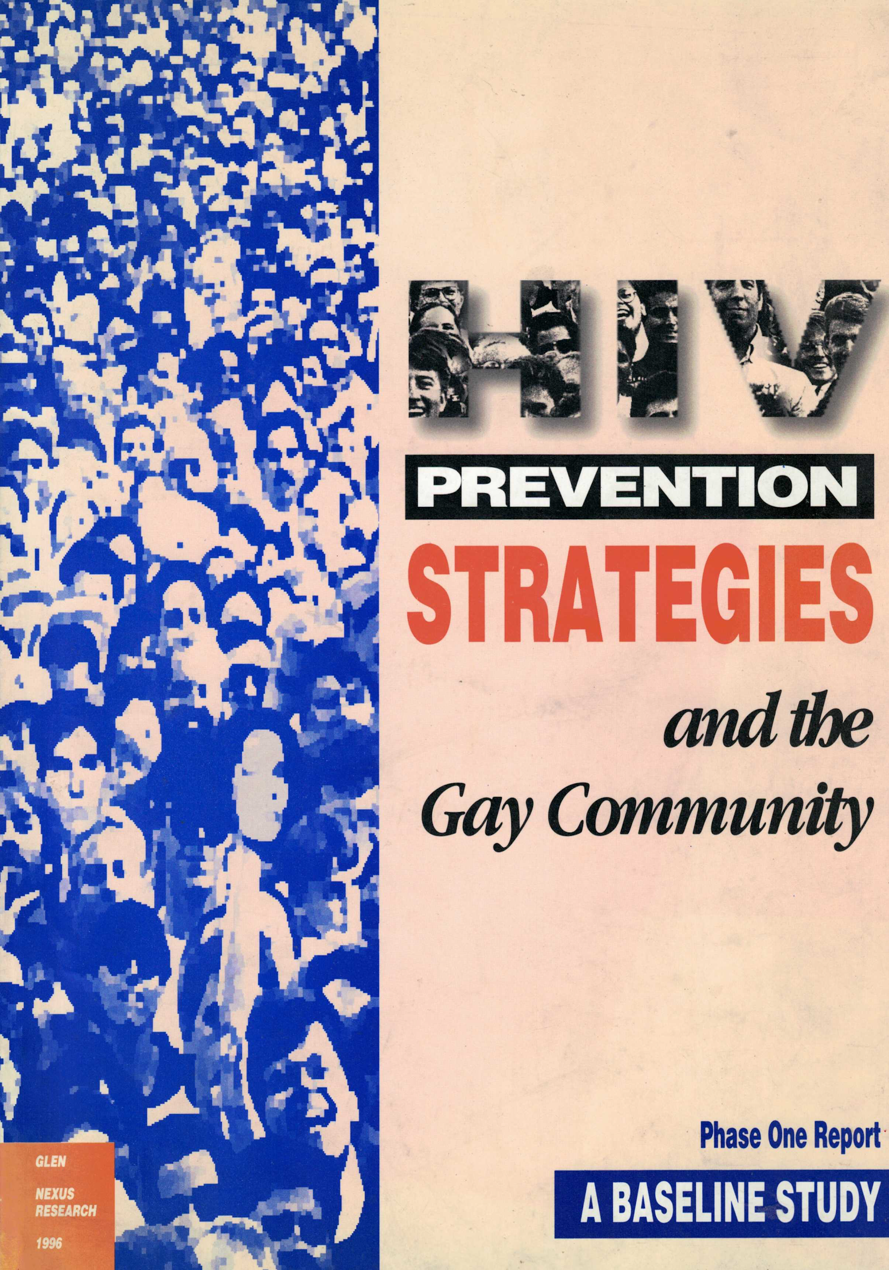
Available on-line: Link to Item http://hdl.handle.net/10147/325026

See www.lenus.ie .. the HSE website of health related reports

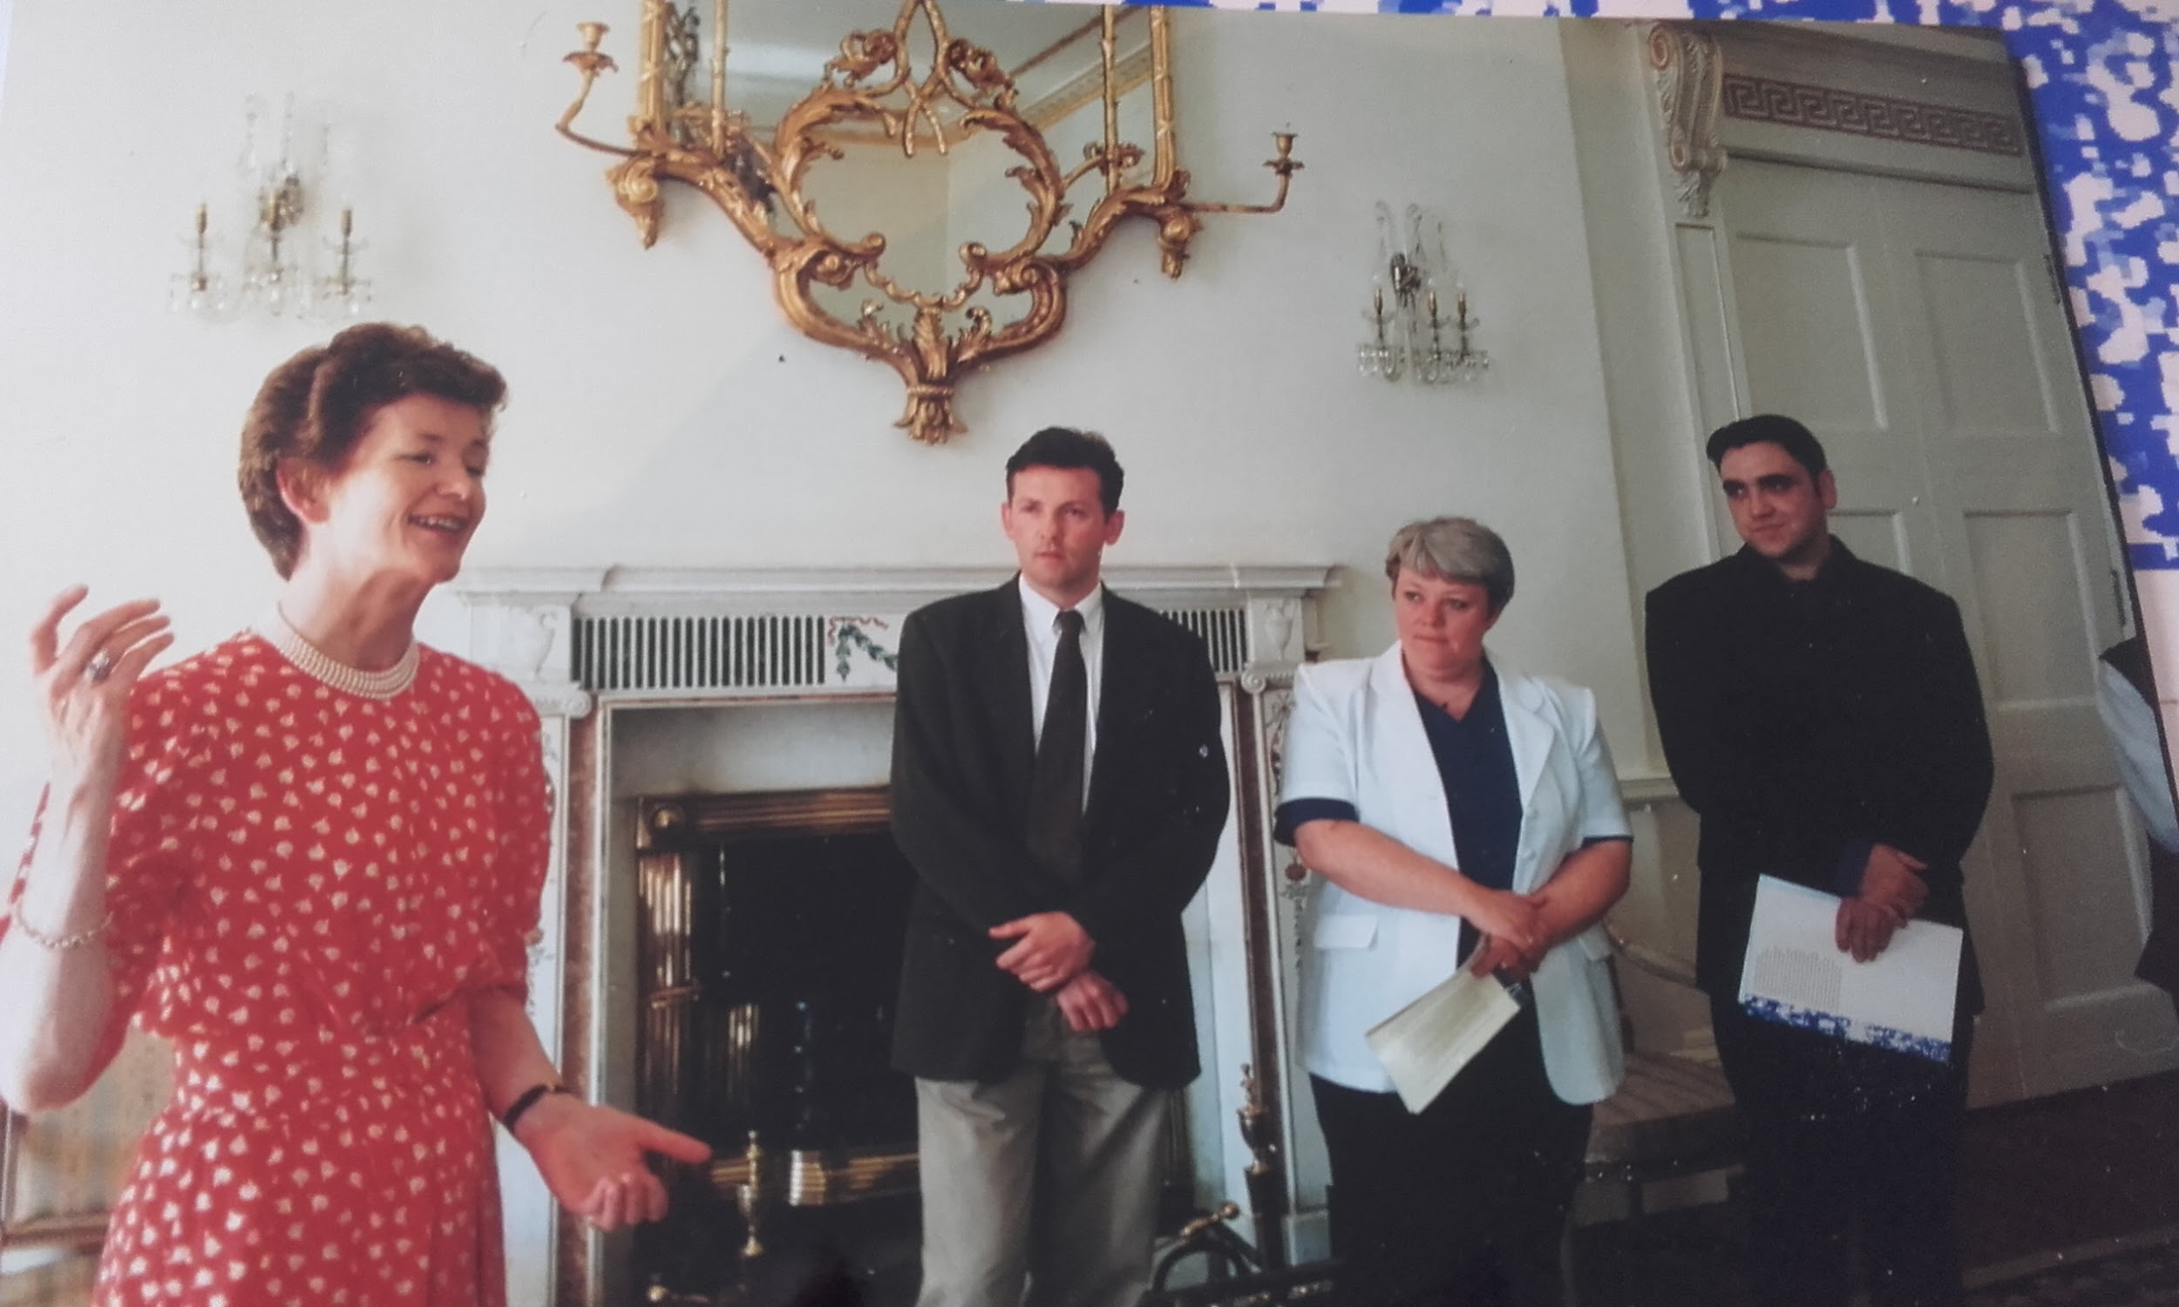
Launch of HIV Prevention Strategies and the Gay Community in Aras an Uachtaran

- Refugee Act 1996
A particular achievement was the explicit protection on the grounds of sexual orientation in the Refugee Act of 1996 by Joan Burton Minister of State at the Department of Foreign Affairs. This was an international first in terms of the explicit inclusion of sexual orientation in refugee legislation and it made explicit:

“membership of a particular social group” includes membership of a trade union and also includes membership of a group of persons whose defining characteristic is their belonging to the female or the male sex or having a particular sexual orientation;

http://www.irishstatutebook.ie/eli/1996/act/17/section/1/enacted/en/html

- Amsterdam Treaty, 1997
The Irish Government as part of its Presidency of the Commission got sexual orientation back into the Amsterdam Treaty with Dick Spring as Minister for Foreign Affairs in 1997 and Fergus Finlay as his advisor. Article 13 prohibits discrimination on the basis of sexual orientation and other and this gives the EU a competency in these matters. This was a breakthrough, and Ireland was responsible

Ireland had the Presidency at the time and GLEN particularly Christopher Robson lobbied Noel Dorr and others to have sexual orientation included. Previously sexual orientation was dropped from the draft Treaty under the Dutch Presidency.

“The Treaty of Amsterdam, which came into force on 1 May 1999, marks a significant milestone for lesbians and gay men in the European Union. The changes introduced by the Treaty include a new clause, Article 13, which covers discrimination on the grounds of sexual orientation, together with sex, racial or ethnic origin, religion, belief, disability and age. This is the first time that any express reference to discrimination on grounds other than sex or nationality has appeared in the Treaties.”
https://www.ilga-europe.org/resources/ilga-europe-reports-and-other-materials/after-amsterdam-sexual-orientation-and-european
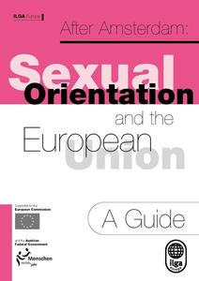

- Social Partnership
It is interesting to note that social partnership was providing opportunities for progress as were our long-standing links with the trade union movement, as well as good working relationships with the employer organisations.

According to the NESF 2003 report: “It should also be noted at the outset that it was agreed in the Programme for Prosperity and Fairness (2000-02) that recommendations emerging from the Equality Authority’s report ‘will be considered by the Social Partners to establish how they might be carried forward’”

In an article for ILGA summarising the situation in Ireland GLEN wrote in 1998:
‘In national negotiations with Government, trade unions and employers, the Community Platform strongly supported the proposal to establish a Task Force on Discrimination against Lesbians and Gay Men .. and called for the expansion of the Community Development Programme with a particular focus on communities of interest such as the gay and lesbian community. The Community Platform is made up of national networks within the community sector which are engaged in combating poverty and social exclusion and promoting equality and justice. GLEN is a member of the Community Platform.’

The National Economic and Social Forum (NESF), in its report on Partnership 2000 (1997-2000): Development of the Equality Provisions (November 1997, pp39-40), recommended the establishment of a Commission or Task Force on the status of lesbians and gay men. The report’s authors concluded: “We are of the view that the extent and nature of discrimination and exclusions on the basis of sexual orientation in this country and the implications for policy, are not widely known or understood and require comprehensive consideration at this time.” The NESF was established by the Government to develop economic and social policy initiatives. Its membership is made up of representatives from Government, Parliament, trade unions, employers and farmers, and those representing groups traditionally excluded (e. g., women, youth, community sectors).

See Philip O'Connor's PhD thesis (DCU) on Social Partnership for an account of how the GLEN programme benefited from Social Partnership.

ILGA-EUROPE: EQUALITY FOR LESBIANS AND GAY MEN A relevant issue
in the civil and social dialogue June 1998

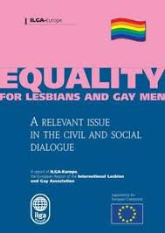

https://mail.google.com/mail/u/0/#inbox/FMfcgxwGDWxSsNPvqXtcqNKmQxGQsNvg

https://documentcloud.adobe.com/link/track?uri=urn%3Aaaid%3Ascds%3AUS%3Ab7320b25-36a2-48f1-9a93-eb5efc29beee

https://documentcloud.adobe.com/link/track?uri=urn%3Aaaid%3Ascds%3AUS%3Ab7320b25-36a2-48f1-9a93-eb5efc29beee

Fourth Periodic Report on the Work of the NESF Report 30 · November 2004
https://documentcloud.adobe.com/link/track?uri=urn%3Aaaid%3Ascds%3AUS%3Ac3f9ce5e-7631-43ae-ab07-8ae129d6200e

- ‘little short of phenomenal’
‘Can the Transition to Individual Protection be Extended to Recognition of Relationships?: Same-Sex Couples and the Irish Experience of Sexual Orientation Law Reform Leo Flynn (c2000), Legal Secretary, Court of Justice of the European Communities

‘Without being wildly optimistic, it is clear that the legal situation of same-sex couples in Ireland is on the cusp of major change’ writes Leo Flynn in a paper c2000 referring to the establishment of the Equality Authority in 1999, the Unfair Dismissals Amendment Act etc. ‘Yet less than a decade ago sexual activity between males was still criminalised ….’ There has been a ‘rolling programme of legislative and policy reform’. The recent developments in Irish law are ‘extraordinary’.

Regarding the equality-based gay law reform he writes: ‘It is arguable that in the ultimate decision to repeal the legislation the Convention played a relatively minor role’ as by 1993 ‘legislative measures had already been adopted which made sexual orientation a protected status in several fields including that of dismissal’ (p5). He goes on to refer to the work of GLEN with the trade unions and other groups. He quotes Christopher Robson to the effect that ‘the move to equal protection in labour law was a more important development [than gay law reform] would have been the first choice of GLEN, if a choice had to be made’. He refers to a number of articles he wrote on such as ‘Discrimination on grounds of sexual orientation’ Employment Law Reports (1993).

‘During the periods it has held the Presidency Ireland has pushed forward important advances in making sexual orientation a Community issue’. ‘Ireland held the Presidency in 1990 when the Council of Ministers adopted a Resolution on the Dignity of Women and Men at work which recognised that sexual orientation-based harassment at work might violate Community law’ (p16). Article 13 of the Amsterdam Treaty was ‘achieved during the Irish Presidency’

He concludes ‘The developments in the Irish legal system in relation to sexual orientation in a decade are little short of phenomenal’ (p17). Regarding the legal recognition of same-sex couples: ‘It is hard to escape th feeling that such recognition will come in the Irish legal system in the medium term’ and ‘Equally, on past record, it is just as likely that the impetus will be domestic’’

- Gay HIV Strategies, 1997

‘Gay HIV Strategies (GHS) is core-funded by the Department of Health and Children with the objective of facilitating new programmes, resources and linkages of effective health promotion, community development and HIV prevention strategies for gay men. The project arises from a needs analysis study commissioned by the Department HIV Prevention Strategies and the Gay Community: A Baseline Study of Resources, Issues and Needs (GLEN/Nexus, 1996). It employs one full-time worker.

GHS understands the social and economic determinants of health as they affect gay and bisexual men. It has successfully developed a range of initiatives with statutory, non-statutory and non-governmental organisations. This includes Government Departments, Health Boards, and Garda Síochána, Community Development Projects as well as the private sector.

A key objective is to develop demonstration projects which can then be mainstreamed. GHS has been effective in modelling ways in which the gay community can work in partnership with Local Authorities, County Development Boards, Health Boards, regional support agencies, local and community development projects, the Garda and youth services in order to create appropriate and accessible services for gay and bisexual men. This groundbreaking work has taken place in urban areas such as Dublin, Cork, and Waterford as well as more rural communities such as those in Louth and Roscommon.’ (From NESF report)

The project director became a member of the National AIDS Strategy Committee which was the first time that a gay community non-statutory representative was appointed, a recommendation of the HIV Strategies report. Regular Progress Reports were sent to NASC. See also Evaluation of Gay HIV Strategies Programme, Department of Health, Brian Dillon/Nexus Research (1999).

The full time worker was based in the Nexus offices in Fumbally Court, the project would not have been possible without this Nexus support.

- EHB funded pilot projects
Christopher Robson and myself met with Pat Mc Loughlin, a senior official in the EHB, to win his support for various actions. Shortly into the meeting as we were putting our case, he interjected and asked us what prectically did we want, we were somewhat taken aback by this as we did not expect to get his support so quickly. In any case we suggested that the EHB make funds available to gay community groups for HIV prevention-related pilot projects. 30,000 punts were quickly made available for innovative pilot projects. Pat McLoughlin was a much-needed ’champion’ at the time and it was a significant breakthrough to get State funding for gay community groups who had never received funding before.

A wide range of projects were funded: ‘A partnership process between the Eastern Health Board and all the major gay community service providers was initiated in 1998. The process involved all the gay community service providers and provided for funding for a range of pilot projects and initiatives including the printing of the Parents Support booklet,5 a needs and strategy analysis of OutYouth (a gay youth group based in Dublin)6, technical assistance for the enhancement of HIV/AIDS coverage in Gay Community News, support for Gay Switchboard Dublin and support for OutHouse, the Dublin gay community centre.’

See also ‘AIDS Strategy 2000: Report of the National AIDS Strategy Committee’ in Appendix
GHS continued to be funded in the post-2006 period.

The EHB was leading the way, but other health boards were doing little. In 1998 GLEN wrote a summary of the situation in Ireland for an ILGA publication: ‘Many regional health authorities have not responded effectively to the HIV/AIDS crisis affecting gay men. And there is strong opposition to progress for homosexuals in some quarters, with the many health and social welfare agencies controlled by the Roman Catholic Church a particular barrier to progress, despite the more constructive approach of many individual Catholics.’

See www.lenus.ie and www.eoin-collins.ie for various reports by Gay HIV Strategies/GLEN

- Garda Síochána

In 1998 Gay HIV Strategies made a written submission to the National Crime Forum and in February 1998 we were asked to make an oral presentation. Professor Bryan McMahon, chair of the Forum suggested to the Gardai present that they meet with the gay community. The various lesbian and gay groups were invited to the Garda HQ and this resulted in the establishment of the Garda Liaison Programme to the lesbian and gay community.

‘NESF report 2003 on An Garda Síochána
‘3.75 The Team commended the Garda Síochána as a good practice model in developing structures for communicating with the LGB community, its organising a three-day seminar in the Garda College Staff with speakers from the LGB community and for the 13 Garda Liaison officers that have now been appointed serving various parts of the country.
3.76 The Team recommends that the Department of Justice, Equality and Law Reform should encourage an evaluation of the Garda Liaison service for the LGB community with a view to mainstreaming the learning gained and its application in other policy areas.’

- Nexus Research Co-operative
From its foundation until it received State funding for a single worker for Gay HIV Strategies, GLEN was an entirely voluntary organisation, with little or no funding, and no office facilities. During this period it relied heavily on Nexus Research Co-operative so that it could send out press releases etc. Nexus supported other civil rights groups such as women's organisations and the campaign against Section 31. Nexus a leading progressive research agency carried out many of the reports and studies we were involved in. Their status and track-record helped us to do joint ground-breaking projects with, for example, the Waterford Area Partnership, and Waterford Regional Youth Services. Gay HIV Strategies were able to quickly, easily and efficiently start work by renting a desk in Nexus and availing of their office facilites.

Eoin Collins was the key link person between GLEN and Nexus, see transcripts of interviews with Eoin Collins by George Gavrilis etc.
GLEN learnt a lot about community development etc. from Nexus

- Mainstreaming and Building Partnerships
These were key strategies for GLEN and GHS. Speaking at a Clar na mBan conference ‘Irish, Queer and Equal?’ in 2000 on our future strategies I said:

‘I think the main one is, we must demand that the State and other institutions deliver those proper services to the gay community. It is not up to the gay community or the lesbian community to deliver half-hearted services that dont meet the rea needs. For example, the educational system, the primary and secondary. It should be an inherent part of the system to respond to the needs of lesbian and gay students. Its not up to lesbians and gay men to go into the off school every now and then to give a talk. The system must deliver’
https://www.slideshare.net/kieranrose/clar-na-mban-irish-queer-equal-2000-belfast

There was a huge lack of easily accessible information on lesbian and gay issues at the time and one example of mainstreaming and partnership is GHS with the NSSB: ‘ As a result of an initiative by Gay HIV Strategies, the National Social Service Board (NSSB) have funded the development and distribution of a package of information with regard to gay/lesbian issues including health and HIV/AIDS. The information package was prepared by Gay HIV Strategies, Gay Switchboard Dublin and Lesbian Education Awareness and was distributed through the 500 information outlets serviced by the NSSB. The NSSB funding also allowed for the production of posters and postcards which are a resource for agencies/organisations to indicate their service is gay friendly.’ (from Waterford report).
Gay HIV Strategies in association with Waterford Regional Youth Services and Southern Gay Health Project (1999) Professional Training for Youth Workers on Issues for Gay Youth: An Outline Proposal, Gay HIV Strategies, Dublin
Eoin Collins worked on all these reports

- ‘Gay Youth and HIV Prevention’ 1997
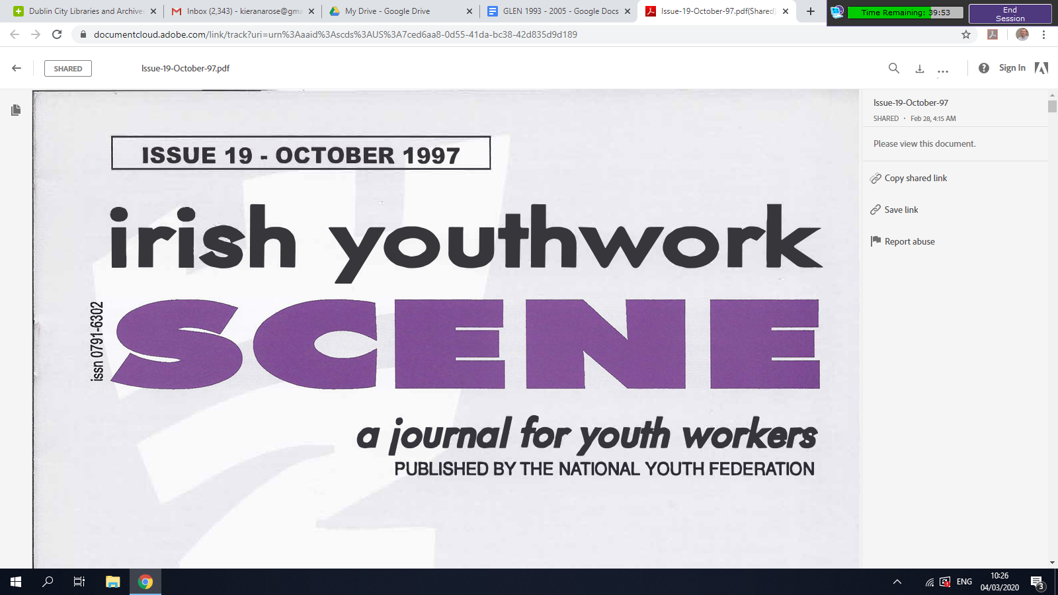
Extract from my article ‘Gay Youth and HIV Prevention’

Getting this article published was significant progress as mainstream youth organisations were usually reluctant/resistant to engaging with lesbian/gay issues, at the time I used to say that it was easier to make progress with the Gardai than it was with youth organisations.

In 1998 we wrote an article for an ILGA report: ‘The provision of youth services is an area where there have been considerable problems, and indeed, until recently mainstream youth services did not respond to the needs of young lesbians and gay men. In fact, lesbian and gay youth issues were often a source of conflict between mainstream organisations and gay youth.’ The rejection of lesbian and gay youth groups by mainstream youth services is set out in 1990 ICCL report ‘Equality Now for Lesbians and Gay Men’.

"I was ostracised by' the majority of my family and forced to leave home because of their fear that my sexuality might lead to HIV infection"
"I was constantly harassed by students In secondary school (at one point attacked). I was also harassed by teaching staff." (GLEN/Nexus, 1995)

These experiences of rejection and harassment are dramatic but not unique to those two young gay people and are a crucial barrier to HIV prevention work. Unfortunately, the well documented needs of gay youth in general and in terms of HIV prevention have been more or less ignored by mainstream youth services. This lack of progress is difficult to explain given the fact that there has been a radical transformation in the public policy in recent years, and in particular with the 1993 law reform which established the equal rights of gay youth. In the absence of outside support and sometimes in the face of strong opposition the gay community and gay youth themselves have tried to respond to the needs of young gay people. However, gay community services available for young people are under resourced,
overwhelmed and confined to the major urban centres. With more and more young people coming out and at a younger age, these services will be increasingly under pressure. More positively, it should be stressed that there is a range of practical initiatives that could be taken in the short-term that would benefit gay youth and enhance mainstream youth services. The clear demand for effective HIV prevention work for young gay men makes the need for such progress all the more urgent.’

ISSUE 19 - OCTOBER 1997, irish youthwork, a journal for youth workers, PUBLISHED BY THE NATIONAL YOUTH FEDERATION

https://documentcloud.adobe.com/link/track?uri=urn%3Aaaid%3Ascds%3AUS%3A7ced6aa8-0d55-41da-bc38-42d835d9d189

From GLEN education report;
‘OutYouth: A Report on the Dublin Gay and Lesbian Youth Group Pilot Project (O’Brien, 1998)2. Describes the results of a pilot project of support for the youth group sponsored by Gay Switchboard Dublin, supported by Gay HIV Strategies and funded by the Eastern Health Board as part of a HIV prevention strategy development process. The report provides very useful information on the factors constraining the development of a group of this kind. It outlines a broad set of recommendations for statutory and voluntary agencies to meet the needs of young gay people.’
See www.lenus.ie and www.eoin-collins.ie

- HIV Prevention in Gay Saunas, 1998

The opportunity to carry out HIV prevention work with the commercial gay sector was identified in the HIV Prevention Strategies report. THis pilot project was funded by the EHB and involved the free supply of condoms, educational material, and educating staff. It was a very successful and these initiatives continued after the pilot project stage hugely improving HIV prevention work and safeguarding peoples health. Getting the EHB funding and logo/endorsement of the project and the report was a very important breakthrough.

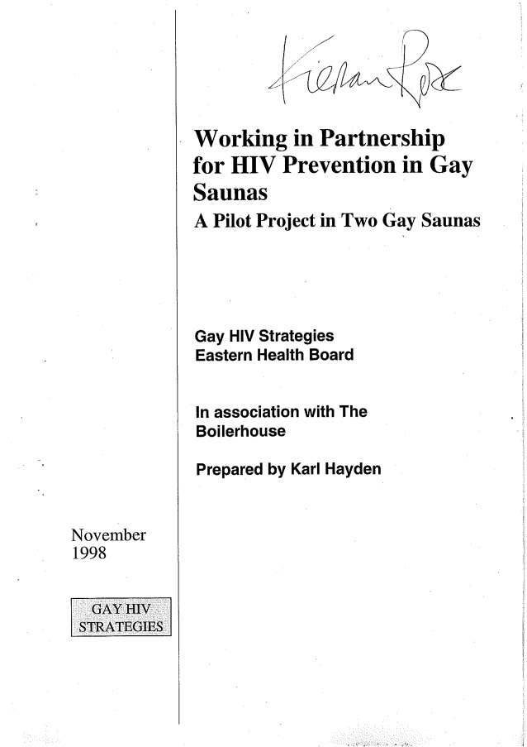

https://www.slideshare.net/kieranrose/working-in-partnership-for-hiv-prevention-in-gay-saunas-a-pilot-project-in-two-gay-saunas

The Sauna report and other health related reports are also available on the HSE website www.lenus.ie and www.eoin-collins.ie

Eoin Collins and Kieran and Christopher wrote the Foreword that sets out the very important historic role of saunas in the development of the gay and

- Waterford Area Partnership and Waterford Regional Youth Services 1999

Nexus contacts in Waterford led to this ground breaking initiative
Eoin Collins and Kieran worked on it
It was very difficult and slow to make any progress
At one stage Eoin and myself joked that the best thing for people in Waterford was to give them money to leave and for us to campaign for Marriage at a national level

According to a report in the Irish Times: ‘A resource report on the gay and lesbian community in Waterford is set to act as a model for other areas.
The study of the needs of lesbians and gay men in the city is unique in that it was funded by Waterford Area Partnership, a development company set up under the 1993 national plan which was drawn up to maximise use of EU structural funds.
Those behind the project hope other area partnerships - particularly those in the south-east region - will follow Waterford's example and set up programmes to tackle the social exclusion problems still encountered by the gay community.
The study, which was carried out by Gay HIV Strategies and Nexus Research, says one of the biggest problems cited by members of the gay and lesbian community in Waterford was the lack of safe and accessible pubs or other social venues for them to meet in and socialise.

Difficulty in obtaining venues for gays and lesbians because of prejudice and discrimination was another serious obstacle to the development of the gay community cited in the report.

The Minister of State, Mr Chris Flood, who launched the report last Friday, said it was clear from the experiences of those who took part in the project that lesbians and gay men were not being encouraged to participate fully in society.’
https://www.irishtimes.com/news/report-on-gays-could-act-as-model-for-others-1.173370

‘But Rose is critical of the national Area Development Management who, he argues, "have done nothing to facilitate the Waterford initiative".
"For local or regional action to be effective there needs to be a major improvement in the support and leadership provided by agencies such as (ADM)." Ed Johnson of ADM, who is responsible for the Waterford area, explains: "We've no problem including groups such as gays in our work on social exclusion but we have a limited budget."’ Irish Times May 1999

https://www.irishtimes.com/news/health/it-hasn-t-gone-away-you-know-1.182869

The report gives a fascinating insight into the difficulties and opportunities for local initiatives for lesbian and gay progress in a small town in 1999, see figure 1 below, later adapted in NESF report. Figure 1: Negative Cycle of Marginalisation and Local Underdevelopment

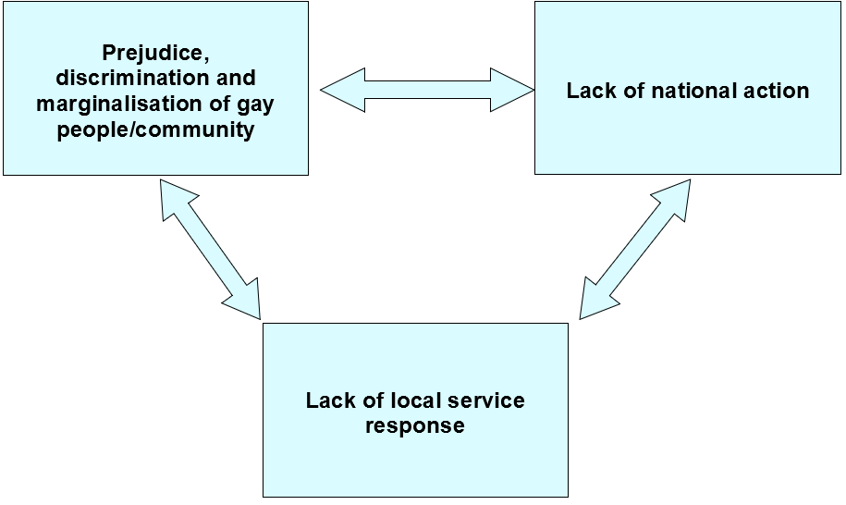

See, Gay HIV Strategies, Nexus Research and Waterford Area Partnership (1999) Local Development: Lesbians and Gay Men: The Report of a Strategy Development and Capacity-Building Project with the Waterford Gay and Lesbian Community.
See www.eoin-collins.ie

The Waterford Area Partnership and Waterford Regional Youth Services were unique in giving such support at the time. Why the other Area Partnerships and other Youth Services in the rest of the country were so reluctant to give such support is a very interesting question
One of the initiatives of the Waterford project was helping to organize Waterford Pride events in 1999.
'Colour in the Streets'
‘Photographs of the lesbian and gay community by Christopher Robson, a Dublin architect and photographer whose work has been featured in the press and many books. The exhibition is a celebration of people, parades & protests photographed mainly in Dublin & New York during the 1990's and receives its premiere in Waterford before touring other venues.’

And Garter Lane Arts centre
http://www.angelfire.com/wa/glamwit/brochure.html

- Education: Lesbians and Gay Men: Developing Equal Opportunities, 2000
Gay HIV Strategies and Nexus Research (2000) Education: Lesbians and Gay Men: Developing Equal Opportunities, Gay HIV Strategies, Dublin

Eoin Collins wrote this report funded by Atlantic Philanthropies, education became a GLEN Strategic priority

‘This comprehensive report is the first to concentrate on the difficulties and problems of gay, lesbian and bisexual students in first and second level education in Ireland. It is in part a follow on from the 1996 Combat Poverty Agency study Poverty: Lesbians and Gay Men: the Economic and Social Effects of Discrimination, which documented the extent of educational disadvantage and underachievement among lesbians and gay men.’

‘Education: Lesbian and Gay Students: Developing Equal Opportunities is a welcome and valuable report. Gay HIV Strategies are to be commended for commissioning this research and for their wider work in this area.’ Niall Crowley CEO Equality Authority
See www.lenus.ie and www.eoin-collins.ie

Education was a key priority for GLEN in the post-2006 period with Sandra Irwin Gowran as Education Director making great progress (see Appendix for two evaluations of GLENs work).

- Implementing Equality for Lesbians, Gays and Bisexuals, Equality Authority, 2002

The extent of discrimination and exclusion experienced by the gay, lesbian and bisexual community is clearly established in this report. This hostility, prejudice and anti-gay sentiment takes numerous forms. Gay HIV Strategies had recommneded such an advisory committee and report. Christopher Robson, Eoin Collins, Brian Sheehan and myself were on the advisory group. The term ‘implementing’ in the title was insisted on by Christopher to stress the need for action.
‘The Equality Authority was assisted in the preparation of this report by an advisory committee involving gay and lesbian organisations, the social partners and representatives of Government Departments.
The recommendations made by the Equality Authority provide an agenda for action in addressing gay, lesbian and bisexual disadvantage in such areas as education, training, employment, services, health, support networks and community development.’ It also recommended a Task Force.
See article by Niall Crowley ‘The Equality Authority and Same-Sex Marriage’ for more detail on the Advisory group, in book on Marriage Equality Referendum edited by Grainne Healy
https://www.ihrec.ie/landmark-report-on-the-status-of-gays-lesbians-and-bisexuals/
https://www.ihrec.ie/documents/implementing-equality-for-lesbians-gays-and-bisexu/
https://documentcloud.adobe.com/link/track?uri=urn%3Aaaid%3Ascds%3AUS%3A897e1621-7b42-4044-88f3-47ef1d20aaba

- NESF, Equality Policies for Lesbian, Gay and Bisexual People:
Implementation Issues
NATIONAL ECONOMIC AND SOCIAL FORUM Report No. 27 April 2003.
See www.eoin-collins.ie

This was an important breakthrough at the time, the first comprehensive engagement by the State with LGBT communities. It was based on a recommendation of the Equality Authority report. Christopher Robson, Eoin Collins, Brian Sheehan and myself were on the advisory group.

The NESF Terms of Reference were: ‘The Project Team on Implementing Equality for Lesbian, Gay and Bisexual People will consult relevant Government Departments and other bodies regarding implementation of the main recommendations of the Equality Authority’s recent report – ‘Implementing Equality for Lesbians, Gays and Bisexuals’.

The Team will, adopting a problem-solving approach, pay particular attention to identifying
potential implementation barriers and challenges on the main priorities, as identified by the Team, and comment and advise on how these may be resolved.’

When the NESF was set up in the 1990s GLEN asked to be included in some way in its consultative structures but were refused by the Minister of State (Labour) responsible.

In later 2000s Eoin Collins of GLEN was funded for a three year period by the Department of Justice and Equality to be liaison officer and carried out a similar engagement process with all Government Depts etc on LGBT issues. This arose from our meeting with Michael McDowell Minister for Justice and Equality.

"Great progress has been made since the gay law reform was introduced in 1993 and we now have some of the most progressive equality legislation in Europe," said Mr Chris Robson, co-chair of the Gay and Lesbian Equality Network (GLEN).

"But the next great legislative change necessary is to provide for lesbians and gay men to have their partnerships recognised in law."
https://www.irishtimes.com/news/campaigners-welcome-report-on-equal-gay-rights-1.484365
It is interesting to note that social partnership was providing opportunities for progress as were our long-standing links with the trade union movement: According to the NESF report: “It should also be noted at the outset that it was agreed in the Programme for Prosperity and Fairness that recommendations emerging from the Authority’s report ‘will be considered by the Social Partners to establish how they might be carried forward’”

- LGB Cycle of Underdevelopment

Based on our experience of trying to make progress and the barriers we encountered we came up with this idea of the ‘cycle of underdevelopment which was included in the 2003 NESF report as follows:
‘Representation and Funding – the lack of an effective and adequately-resourced infrastructure to help LGB people better inform and input their views into the policy-making process was highlighted as a barrier on a number of occasions during the Team’s consultations. Even bodies well versed in other equality issues may not appreciate the specific concerns and issues arising for other groups such as LGBs. The lack of visibility of LGB groups in policy design and review and the tendency for LGB issues often not to be specifically addressed in policy and practice were main contributory factors in this regard.

The Team concluded that addressing representation and funding is a key requirement to reducing the barriers that exist to policy improvements and effective implementation in this area. This would have beneficial outcomes for LGB people, Government Departments and society in general.

The Team recommends that:
• All Boards of State Agencies charged with pursuing equality and social inclusion issues should ensure that they have adequate expertise and timely advice regarding the specific needs of the LGB community, particularly those who are cumulatively disadvantaged. • Disadvantaged LGB people should be explicitly targeted as a vulnerable group under the NAPS, in the same way that women are.

• As an immediate stop-gap response to the needs of LGB groups, the Department of Justice, Equality and Law Reform should consider providing funding to LGB organisations to develop their infrastructure and facilitate their input to policy-making.
(This recommendation was implemented when GLEN got a 3 year grant from the Department of Justice and Equality to employ a liaison person, Eoin Collins took on this role)

• In the design and operation of funding schemes under equality, community development and social inclusion programmes, it should be borne in mind that within any group in Irish society (e.g. women, ethnic minorities, and poor people) there will be members who are also lesbian, gay or bisexual. For this reason, organisations representing lesbians, gays and bisexuals should, in principle, be eligible for such funding.’

The report noted that: ‘Six LGB organisations have developed proposals for funding under the CDP, which were submitted to the Department in December last, together with an application for a national support agency.’ It referred to a study by Brian Dillon of Nexus Research, (2002) ‘Implementing a Community Development Approach to Tackling Gay and Lesbian Social Exclusion. Dublin: Gay HIV Strategies.’

The fact that lesbian and gay community initiatives were not State-funded and were not included in consultation frameworks meant that they existed in ‘parallel universes’ I wrote at the time; see Kieran Rose: Parallel Universes: The Lesbian & Gay Communities & Local Development, in: Local Development in Ireland, published by the Community Workers Cooperative in 1998.

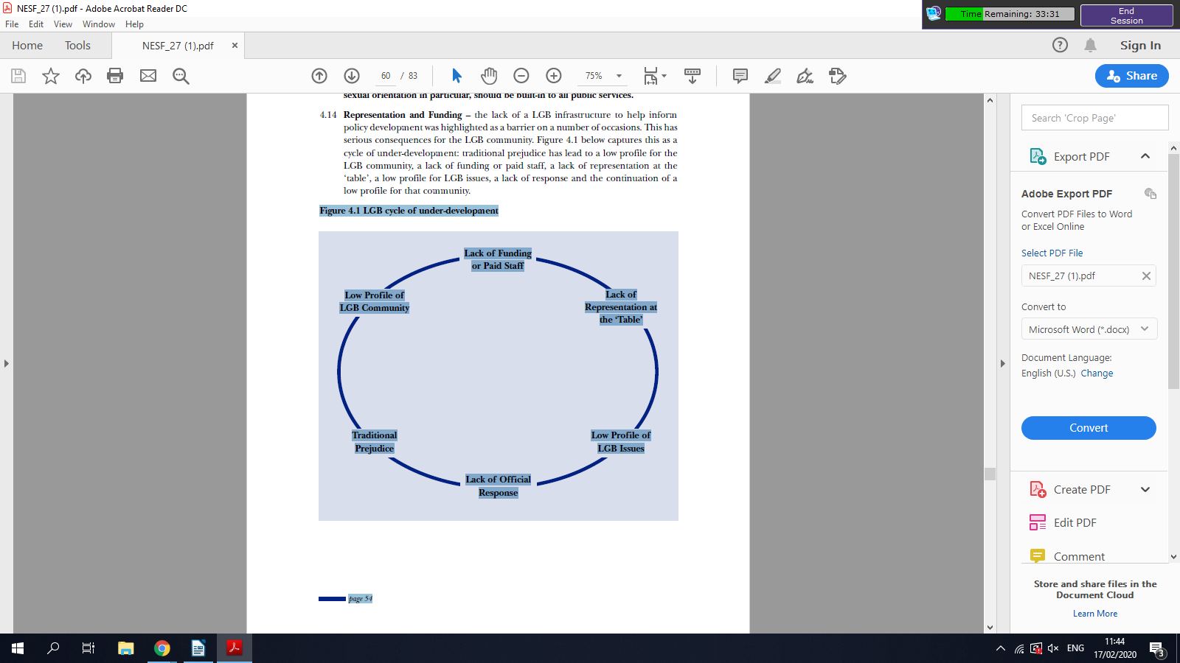

- Lack Equality Policy Implementation

The NESF in 2008 reviewed progress on the recommendations of its 2003 report stating:‘In undertaking this work, the NESF was aware of the many worthwhile recommendations that had been made over the years in a range of well regarded reports but these had been neglected or at best were not as fully acted on as they should have been.The missing link in this was the gap between policy design,on the one hand,and policy implementation on the other and the absence of coherent mechanisms or models to follow through on this.’
https://documentcloud.adobe.com/link/track?uri=urn%3Aaaid%3Ascds%3AUS%3A8eee44b1-4092-4366-99fa-5aa43554cfe7
https://mail.google.com/mail/u/0/#inbox/FMfcgxwHMGBFXwRVQkxMlhZQckggtdNq

Here are some examples of lack of implementation, from an article for ILGA on Ireland GLEN wrote in 1998:
- ‘The Department of Social, Community and Family Affairs 1997 Green Paper on the community and voluntary sector, Supporting Voluntary Activity, recognised the role of organisations representing the lesbian and gay communities and stated that networks concerned with gay and lesbian issues could be eligible for funding under the category of national anti-poverty networks.’ However little or no funding resulted.

- ‘The Area Development Management (ADM), a government organisation set up under the European Union Structural Funds programme with the objective of combatting disadvantage, has developed anti-discrimination guidelines which include sexual orientation.’ Yet little or no funding resulted.

- ‘The Department of Education’s Expert Advisory Group on Relationships and Sexuality Education recommended in 1994 that sexual orientation should be included in the post-primary senior cycle, and that HIV and AIDS education should be included much earlier, in the senior stage of the primary level.’

However writing in 2006 Eoin Collins sets out: ‘The Garda Síochána in particular have taken a number of important strategic steps to make the police service more responsive to the reality of anti-gay violence. However, progress in many other areas is less apparent. For example, despite the best efforts of individuals within the education sector, very limited systemic action has been taken to address the reality of bullying and harassment experienced by young lesbian,
gay and bisexual (LGB) people, or those perceived to be LGB, at school.’ (Reviewing Progress on Equality for Lesbian, Gay and Bisexual People, Equality News, Spring 2006)

The NESF continued: ‘The Department of Justice Equality and Law Reform has also funded a policy liaison post in GLEN for three years to end-2008 and has been facilitating meetings between GLEN and Departments and Agencies on policies, programmes and services which impact on the LGB group. GLEN was chosen because they are a non-governmental policy-focused organisation that has campaigned for the welfare of LGB people and for their right to equality since 1988.’

‘Nine Government Departments have met with GLEN to discuss issues in each department relating to the needs of LGB clients or service users.’

However, it noted the limited progress made in funding LGB groups on community development and social inclusion programmes.

The NESF reiterated its recommendations and added new ones.

- "Mental Health: Lesbians and Gay Men - Strategies to Promote the Mental Health of Lesbians and Gay Men" 2004
See www.eoin-collins.ie
‘This is the first Irish report to concentrate solely on the experience of gay men and lesbians with regard to mental health. The impetus for this research initiative came from a number of representations made to both Gay HIV Strategies and the Northern Area Health Board (NAHB) in 1999. The NAHB had been contacted by members of the gay community about concerns regarding the rate of suicide amongst this group. The work completed by Gay HIV Strategies on areas such as HIV prevention and education also identified mental health as a key area of concern. A partnership developed between Gay HIV Strategies and the NAHB that began with the organisation of a number of information seminars.

We believe that the partnership between the Northern Area Health Board and Gay HIV Strategies will continue and can work with other agencies to realise the recommendations identified in this report.’
Gay HIV Strategies and Health Promotion Department (NAHB) June 2004

https://www.lenus.ie/handle/10147/266932?show=full

Eoin Collins wrote this report and available on www.lenus.ie

As a result of that report we got funding for a part-time strategy worker on mental health from the health board, Eoin Collins took on this role.

Mental Health was a key work area for GLEN post-2006 and Odran was Director of Mental Health in that period making great progress (see two evaluations of GLENs work post -2006).

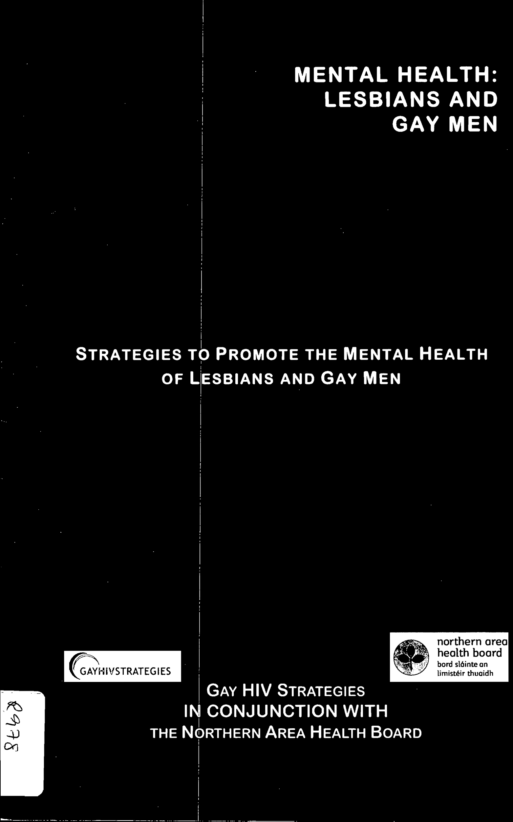

- making equality a reality in people's everyday lives
At the Clar na mBan seminar in 2000 there was a qustion put to the panel along the lines of: ‘Have we as a gay and lesbian movement become too focussed on legislative change and legislative success?’

I replied saying that the legal changes such as gay law reform and equality legislation etc were vital and continued:
‘We absolutely do need those legal protections and we absolutely do need an Equality Authority, - thats its not just up to us to vindicate our own rights. Its a state-funded organisation with considerable statutory powers, with people like Marie [Mulholland] employed to do that kind of work for us and a number of other groups. And we absolutely do need and deserve that type of response from the state.

But I totally agree with you that is only, merely a beginning, that is merely a platform and making equality a reality in people's everyday lives is a totally different struggle and a totally different issue, and that struggle is going to be very, very difficult. Change is very, very slow and its going to be very very slow trying to get a young gay man or a young lesbian student in school at 9 or 13, to provide them with an education environment that suits them, where they can progress as is necessary for them educationally and socially and every other way. That is making a reality out of equality in people's everyday lives. That's making a reality out of the policy and the legal changes we have brought about, and that is a very different struggle. That's the next struggle we must take on’.

Concluding I said; ‘Theres one thing that Gerry Adams raised in terms of strategy and tactics and I think thats a very important thing for the lesbian and gay movement. Sometimes I think we want to be right all the time and sometimes we would prefer to be right than to be successful and I think that's a choice we have to make and in our campaigning we have to really consider that there are costs both ways. In the long run we are all dead , so if it's all to work out in 60 years time it's too late …..’

- Developing ‘Building Sustainable Change’, GLEN Strategic Plan 2006 - 2010

‘As a prelude to funding the full BSC Programme, the Atlantic Philanthropies provided 'seed' funding so that GLEN could develop its strategic programme and begin to resource the organisation (€266,000 in 2004/05). This 'seed' funding enabled GLEN to recruit a Director and Administrator and to develop the BSC Programme to a point where it could be funded as an investment programme. Atlantic committed over €2m to GLEN for the 5 year programme which outlined an ambitious change agenda to advance equality for LGB people. The programme essentially formalised and put a structure on what had been an intuitive strategic process for GLEN up to then.’

‘The critical drivers shaping GLEN's strategic ambition can be traced back to the Equality Authority report on Implementing Equality for Lesbians, Gays and Bisexuals, and the subsequent report by the National Economic and Social Forum (NESF) on Implementation Issues.’

The strategy was also built on all our previous experience and from the various studies and projects we were involved in. We set out the following ambitious vision, and with a sense of urgency as we knew from our experience of the ‘cycle of underdevelopment’ etc that the significant Atlantic Philanthropies funding was a ‘once in a lifetime opportunity’ to transform the situation for lesbians and gay me in Ireland:

‘The goal of the programme is not about managing our marginalisation, but abolishing it, and therefore making GLEN redundant in the shortest possible time. The Building Sustainable Change programme is ambitious for Ireland and ambitious for our communities. It aims towards a society where being gay is unremarkable; where people can aspire to be openly gay as Taoiseach, CEO, teacher, nurse, construction worker or any occupation they choose. It works towards a society where a young gay or lesbian person can come to terms with their sexuality, confident of support from their family, friends, school and society at large. It seeks to ensure that LGB people can form their own relationships and families and have these recognised on an equal basis with others1’
Eoin Collins was a key GLEN thinker and strategist and had a critical role in the development of this ambitious Plan
See www.eoin-collins.ie
Launching the Strategic Plan in April 2006 in Fumbally Court, An Taoiseach Bertie Aherne said in a powerful and detailed speech (see Appendices):
‘I want to state clearly today that the Government is unequivocally in favour of treating gay and lesbian people as fully equal citizens in our society. …………..
Our sexual orientation is not an incidental attribute. It is an essential part of who and what we are. All citizens, regardless of sexual orientation, stand equal in the eyes of our laws.
Sexual orientation cannot, and must not, be the basis of a second-class citizenship. Our laws have changed, and will continue to change, to reflect this principle.’
In an opinion piece about the event I wrote: ‘Previously many gay people had to emigrate for two reasons; to get a job and to be in a society where it was possible to live openly and happily as gay; now gay people are coming to this country for the same two opportunities. The Taoiseach, launching the GLEN (Gay and Lesbian Equality Network) ‘Building Sustainable Change’ programme and his opening of the GLEN offices is a symbol and an encouragement of this progress.
This raises the issue of what progress still needs to be made. The key outstanding legal issue for lesbians and gay men is the recognition of our intimate relationships. There is no reason why there should not be an equality of rights and responsibilities for all, in other words civil marriage for same-sex couples. As a country our self-confidence has increased fundamentally - we now have a ‘can-do’ success-orientated approach.’ (see Appendices for full article)

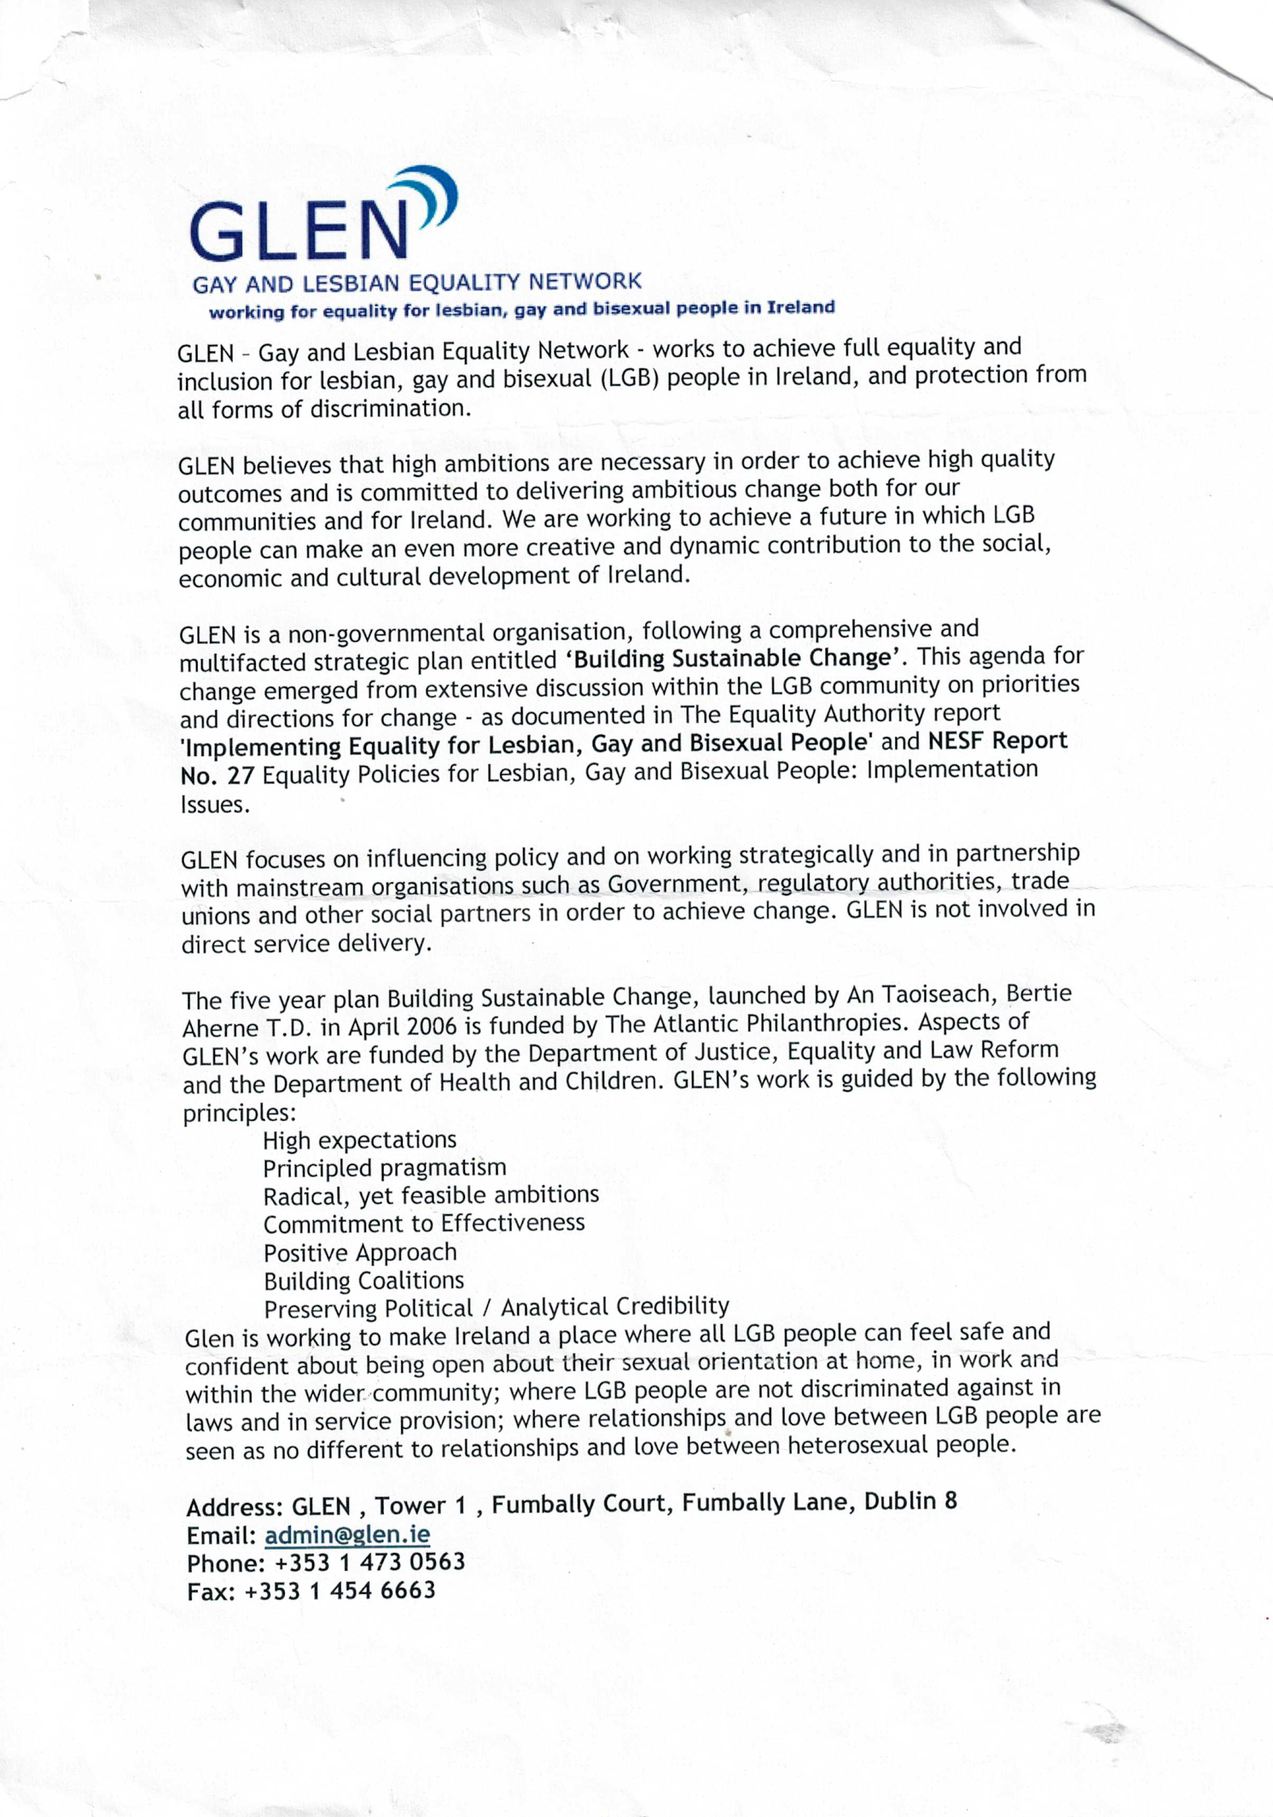

Appendices

‘From Individual Protection to Recognition of Relationships? Same-Sex Couples and the Irish Experience of Sexual Orientation Law Reform’
Leo Flynn, Legal Secretary, Court of Justice of the European Communities, Luxembourg (Lecturer, School of Law, King's College, University of London)
In; Legal Recognition of Same-Sex Partnerships (2001), A Study of National, European and International Law, Editors: Robert Wintemute is Professor of Human Rights Law in the School of Law, King's College London. Mads Andenas is Professor of Law at the University of Leicester.

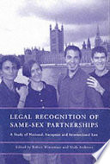

Gay HIV Strategies (1997) Developing Accessible and Appropriate Services for the Gay Community, Submission to Department of Health and Children Customer Action Plan.

Gay HIV Strategies (1998) Submission to the National Crime Forum.

Gay HIV Strategies (1998) Submission to Department of Justice, Equality and Law Reform, The Law on Sexual Offences., A Discussion Paper.

Gay HIV Strategies (1998) Submission to National Policy on Libraries and Information Services.

Gay HIV Strategies (1998) Submission to the Dept. of Social, Community and Family Affairs, Green Paper on the Community and Voluntary Sector.

Gay HIV Strategies (1998) Submission to the Working Party on Juvenile Justice.

Gay HIV Strategies (1998) Submission to the Draft Second report by Ireland under the International Covenant on Economic, Social and Cultural Rights.

Gay HIV Strategies (1998) Submission to the Combat Poverty Agency Strategic Plan.

Gay HIV Strategies and Karl Hayden (1998) Working in Partnership for HIV Prevention in Gay Saunas: A Pilot Project in Two Gay Saunas. Eastern Health Board.
See www.lenus.ie

Gay HIV Strategies (1998). Submission on Human Rights Commission to Department of Justice, Equality and Law Reform.

Gay HIV Strategies (1999). Submission to the Review of the National AIDS Strategy.

Gay HIV Strategies (1999) Submission to Department of Finance on National Development Plan.

Collins, Eoin (2000) Promoting Equality for Lesbians and Gay Men: Scoping Study on International Best Practice, Nexus Research, Dublin, Equality Authority

Gay HIV Strategies in association with Waterford Regional Youth Services and Southern Gay Health Project (1999) Professional Training for Youth Workers on Issues for Gay Youth: An Outline Proposal, Gay HIV Strategies, Dublin

Nexus Research (1998) OutYouth: A Report on the Dublin Lesbian and Gay Youth Group Pilot Project, Gay Switchboard, Dublin
See www.lenus.ie

Dillon, B. (2002) Implementing a Community Development Approach to Tackling Gay and Lesbian Social Exclusion. Dublin: Gay HIV Strategies.

Evaluation of Gay HIV Strategies Programme Irish Department of Health, Brian Dillon (1999)
See www.lenus.ie

Gay HIV Strategies, Nexus Research and Waterford Area Partnership (1999) Local Development:.Lesbians and Gay Men: The Report of a Strategy Development and Capacity-Building Project with the Waterford Gay and Lesbian Community, http://www.glen.ie/public/pdfs/Waterford%20Final%20Report
%201999.pdf

‘Cooperation Key to HIV Prevention’ Kieran Rose ‘Poverty Today’ 1998

Kieran Rose: Parallel Universes: The Lesbian & Gay Communities & Local Development, in: Local Development in Ireland, published by the Community Workers Cooperative in 1998, discusses the potential of EU funded local development programmes to combat social exclusion.

The Government Ombudsman’s Guide to Standards of Best Practice for Public Servants includes sexual orientation in an anti-bias clause.

‘Access to health services for transsexual people’, Eoin Collins, Brian Sheehan, Equality Authority 2004
Www.ihrec.ie
https://www.lenus.ie/handle/10147/44869

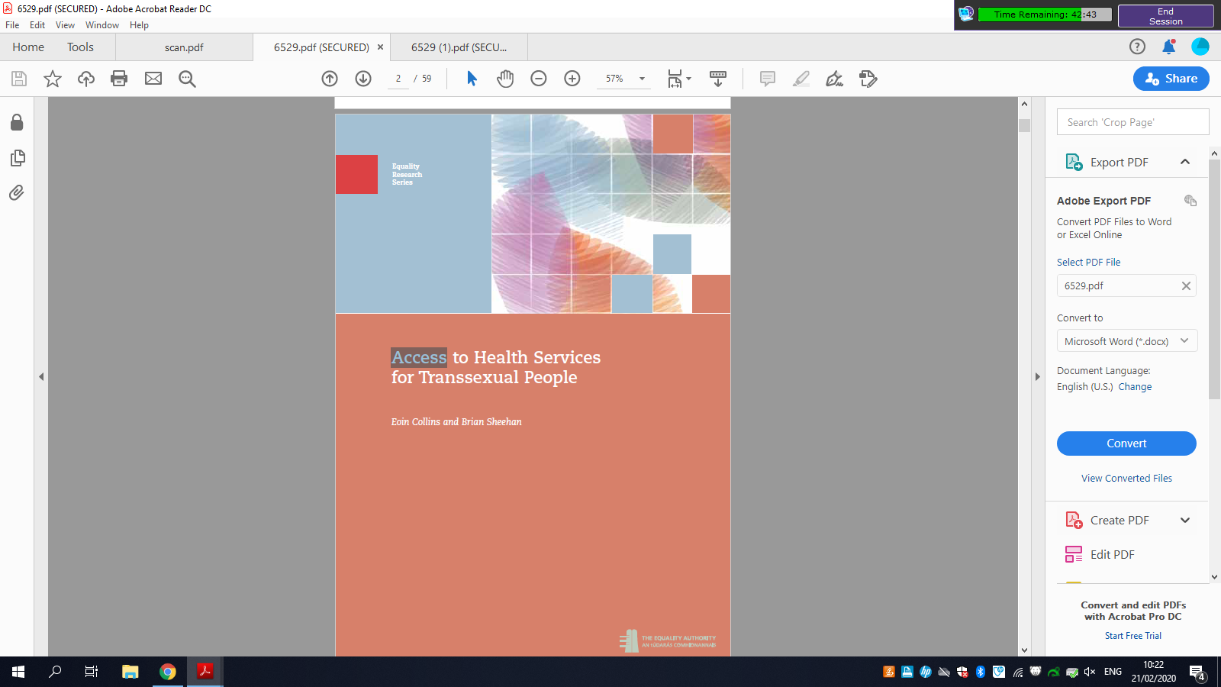

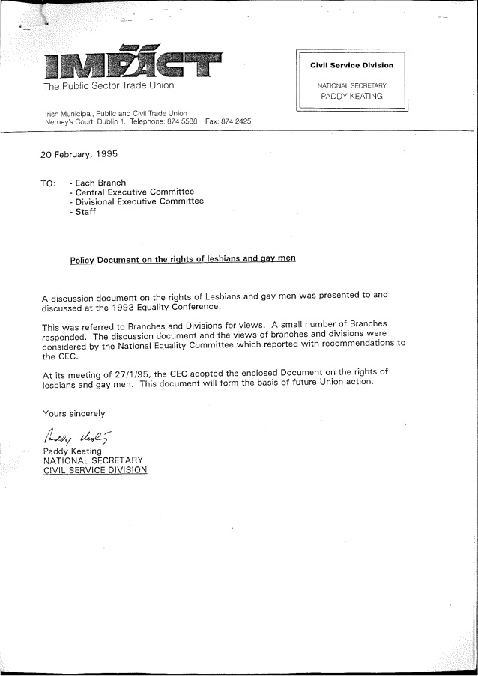

AIDS Strategy 2000
Report of the National AIDS Strategy Committee

‘The 1993 Criminal Law Sexual Offences Act which decriminalised homosexual acts provided for equality with heterosexuals and was a fundamental shift in public policy towards the gay community. Research commissioned by The Combat Poverty Agency13 and The Department
of Health and Children14 have provided essential data on the experiences of gay men which.were not available in 1992. The Combat Poverty report illustrated how the gay community is.a marginalised or socially excluded community, a fact which impacts on health status. There has been a developing policy response to discrimination, poverty and social exclusion of the gay community. One example of this is the National Anti-Poverty Strategy and its Poverty /
Equality Proofing Guidelines. The further integration into mainstream programmes of
responses to gay disadvantage, particularly those aimed at gay men experiencing multiple disadvantages, would be of great benefit to HIV prevention programmes. The initiative launched by the Waterford Area Partnership could be viewed as a model of good practice in this regard. The net effect of policy improvements is to create a healthier environment and reduce the sense of marginalisation of gay and bisexual men and women, which in turn should provide a context for healthier choices.

Gay HIV Strategies, funded by the Department of Health & Children, was formed in 1997 and has played an active role in policy development and capacity building. One of their aimsis to gain funding for HIV prevention pilot projects and to build the capacity of the.community groups to engage in health promotion and HIV prevention work. They have illustrated the benefits of a partnership approach through the pursuit of another of its aims, which was to improve education and awareness of safer sex in the gay commercial sector. TheSauna Project, as this initiative is called, developed a partnership process between the sauna
owners, management and staff, the customers, the various health service providers and the gay community service providers so that effective HIV prevention measures were developed and Implemented.

It is recommended that since partnership and capacity building is an effective strategy for
working with marginalised groups, this approach should continue.
It is also recommended that funding for appropriate literature should continue’

Men who have sex with men: HIV prevention among those who are HIV positive: a resource paper 2 0 0 5
E O I N C O L L I N S A N D B R I A N S H E E H
From GLEN education report

• Professional Training for Youth Workers on Issues for Gay Youth: An Outline Curriculum Proposal (Nexus Research/Gay HIV strategies, forthcoming) was sponsored by Waterford Regional Youth Services and Southern Gay Health Project. The curriculum proposal contained in the report was developed following a detailed literature review, interviews conducted with key personnel in youth services agencies and two pilot professional development sessions held with youth workers on issues of health promotion for gay youth.
Written by Eoin Collins
See www.lenus.ie

The National Anti-Poverty Strategy (NAPS) report Sharing in Progress (Government of Ireland, 1997: 71-72), which dealt with issues of discrimination and inequality, recorded that evidence has been documented on discrimination leading to poverty for a number of groups and referred to Travellers (Report of the Task Force on the Travelling Community) and lesbians and gay men (Combat Poverty Agency, 1995). It also referred to the "ongoing debate on the extent to which discrimination can increase the risk of poverty for some groups in society". It stated that: "While homosexuality in itself does not necessarily place one at risk of poverty, the impact, experience and perception of discrimination may limit the full participation of gay men and lesbians in society, and may in some cases place them at risk of poverty"

A partnership process between the Eastern Health Board and all the major gay community service providers was initiated in 1998. The process involved all the gay community service providers and provided for funding for a range of pilot projects and initiatives including the printing of the Parents Support booklet,5 a needs and strategy analysis of OutYouth (a gay youth group based in Dublin)6, technical assistance for the enhancement of HIV/AIDS coverage in Gay Community News, support for Gay Switchboard Dublin and support for OutHouse, the Dublin gay community centre.

RTE's screening of its first documentary on being gay in Ireland received a positive response from the public, according to the station.
The documentary, called The Love That Dare Not Speak Its Name, was broadcast on RTE 1 on Tuesday night [20000] and was followed by the film Beautiful Thing, a gay love story.
While various programmes have touched on the subject this was the first time that an hour-long documentary had explored homosexuality in Ireland.
The programme was described as a "fundamental, seminal broadcast from RTE" by Mr Brian Sheehan, Gay/HIV Strategies director. "It was wonderful to see something like this on RTE at last and it will create a visibility of a different order for gay men and women in Ireland."

https://www.irishtimes.com/news/positive-reaction-to-gay-programme-1.1259476

‘The Gay Community Response to the Emergence of AIDS in Ireland: Activism, Covert Policy, and the Significance of an “Invisible Minority”’

https://www.cambridge.org/core/journals/journal-of-policy-history/article/gay-community-response-to-the-emergence-of-aids-in-ireland-activism-covert-policy-and-the-significance-of-an-invisible-minority/4A209E10B4BE0EC42B97789A7BAB021B/core-reader

The Gay Community Response to the Emergence of AIDS in Ireland: Activism, Covert Policy, and the Significance of an “Invisible Minority”

Article (PDF Available) in Journal of Policy History 30(01):105-127 · January 2018 with 183 Reads

The Department of Social, Community and Family Affairs.1997 Green Paper on the community and voluntary sector, Supporting Voluntary Activity, recognised the role of organisations representing the lesbian and
gay communities and stated that networks concerned with gay and lesbian issues could be eligible for funding under the category of national anti-poverty networks.

The Department of Education’s Expert Advisory Group on Relationships and Sexuality Education recommended
in 1994 that sexual orientation should be included in the post-primary senior cycle, and that HIV and AIDS education should be included much earlier, in the senior
stage of the primary level.

The Government Ombudsman’s Guide to Standards of Best Practice for Public Servants includes sexual orientation in an anti-bias clause.

The Area Development Management (ADM), a governmen organisation set up under the European Union Structural Funds programme with the objective of combatting
disadvantage, has developed anti-discrimination guidelines which include sexual orientation.8
One of the Local Area Partnerships funded by ADM is itself funding a pilot project to build the capacity of the gay community to engage in developmental work.

In national negotiations with Government, trade unions and employers, the Community Platform strongly supported the proposal to establish a Task Force on Discrimination
against Lesbians and Gay Men (see above) and called for the expansion of the Community Development Programme with a particular focus on communities of interest such as the gay and lesbian community.
The Community Platform is made up of national networks within the community sector which are engaged in combating poverty and social exclusion and promoting
equality and justice. GLEN is a member of the Community Platform.

The Community Development Programme
is run by the Department of Social Welfare and it provides core funding for resource centres to develop the he capacity of local communities to work together to tackle poverty and social exclusion.

A key recommendation of the report was the establishment of a Task Force composed of representatives from government departments, the gay community, and
others to initiate action on the advantages identified in the report. This recommendation was subsequently supported by the National Economic and Social Forum (see
above).

Partnership 2000: Development of the Equality Provisions,
November 1997, National Economic and Social Forum, pp. 39-40.
This is the first in a series of six monthly opinions which the Forum has been asked to prepare under the arrangements which have been put in place to benchmark and monitor the Partnership 2000 Agreement. Partnership 2000 is an agreement between the Government and the social partners on pay, taxation and other economic and social policies.

EQUALITY FOR LESBIANS AND GAY MEN; A relevant issue in the civil and social dialogue
June 1998
https://mail.google.com/mail/u/0/#inbox/FMfcgxwGDWxSsNPvqXtcqNKmQxGQsNvg

‘Report on gays could act as model for others

Wed, Apr 14, 1999,
‘A resource report on the gay and lesbian community in Waterford is set to act as a model for other areas.
The study of the needs of lesbians and gay men in the city is unique in that it was funded by Waterford Area Partnership, a development company set up under the 1993 national plan which was drawn up to maximise use of EU structural funds.
Those behind the project hope other area partnerships - particularly those in the south-east region - will follow Waterford's example and set up programmes to tackle the social exclusion problems still encountered by the gay community.
The study, which was carried out by Gay HIV Strategies and Nexus Research, says one of the biggest problems cited by members of the gay and lesbian community in Waterford was the lack of safe and accessible pubs or other social venues for them to meet in and socialise.
This led to considerable isolation, particularly for those who, through lack of money or other constraints, were unable to travel to gay venues in Dublin or Cork. Other issues raised included harassment and violence, with some reporting that coming out as gay in Waterford had had a negative impact on their lives. One person who attended a meeting in the preparation for the study last year described being continually harassed at his workplace, a local factory, while another was attacked in the area in which he lived because people had assumed he was gay.
Difficulty in obtaining venues for gays and lesbians because of prejudice and discrimination was another serious obstacle to the development of the gay community cited in the report.
The Minister of State, Mr Chris Flood, who launched the report last Friday, said it was clear from the experiences of those who took part in the project that lesbians and gay men were not being encouraged to participate fully in society.

Mr Flood, who has responsibility for local development and is also a member of the Cabinet committee on social exclusion, said everyone had a right to participate fully in the economic and social life of their local community, and to feel they had a valuable contribution to make.
If the Waterford report has bleak stories to tell about the experiences of the gay community in the past, local activists believe it could provide the basis for a more positive future. Alan Brett, secretary of the GLAM (Gay, Lesbian and Mixed) Society at Waterford Institute of Technology, says gay organisations will now be taken more seriously.
"When we go looking for funding now, we have this report to back us up," he says. What's really needed at this stage, he adds, is for some entrepreneur to recognise the business potential in having a regular venue for gay people in Waterford and outlying areas to meet, just as they have in Dublin, Cork, Galway and Limerick.
A resource group has already been established as a result of the report, comprising lesbian and gay representatives and members of mainstream development bodies like Waterford Area Partnership.
The partnership's community development co-ordinator, Mr Ger Doyle, says it will continue its support for the gay community development process, as the report recommends.
It also hopes to initiate joint ventures with the three other partnerships in the south-east, - Waterford County, Wexford Area and Co Wexford - to develop regional initiatives to combat social exclusion as it affects lesbians and gay men.’
https://www.irishtimes.com/news/report-on-gays-could-act-as-model-for-others-1.173370

‘It hasn't gone away, you know
Mon, May 10, 1999, 01:00
‘Hardly a day passed in the early 1990s without AIDS making the headlines. Whether it was grim projections of death tolls, news of drug research or advice on prevention, the issue was constantly in the spotlight.
Some 332 people have died of AIDS-related illnesses in the Republic since 1985, according to the Department of Health's most recent statistics. A further 650 AIDS diagnoses are recorded and 1,986 people are reported to have HIV infection.
These figures are at least somewhat more detailed than those available several years ago. Breakdown by age, for example, is now given for newly reported infections, although a regional breakdown for infections is still incomplete. Figures for the Eastern Health Board (EHB) area are recorded separately but all other health board areas are combined into one - a method is far from adequate for targeted HIV prevention strategies.
The general emphasis of the way in which the information is presented focuses on AIDS diagnoses and related deaths, effectively playing down HIV prevention. In fact, the spending on HIV prevention by the Department's Health Promotion Unit has been a paltry £160,000 for each of the past two years.
Given that AIDS has largely disappeared from headlines recently and that the money spent on HIV prevention wouldn't buy you a second-rate TV commercial for a detergent, it is all the more alarming to see that newly reported HIV infections for the years 1985 to 1998 continue to rise steeply (see graph). HIV and AIDS may have disappeared from the news, but the problem has certainly not gone away.
The Government's figures on HIV and AIDS among intravenous drug users, on whom most of the Eastern Health Board's resources and energy and focused, shows targeted HIV prevention strategies do work. The figures for reported new infections among HIV drug users (see graph) indicate a levelling-off of infections in this target group. The Government is to be commended for this sustained and necessary action. But what about other groups susceptible to HIV infection?
With such concentration of resources on drug users, a glaring need exists for similar effort to be put into HIV-prevention work with gay men - while the numbers of HIV cases fall among drug-users, figures for newly reported HIV infections among gay men show sharp increases. Clearly, there is a direct correlation between not spending money in a strategic and comprehensive way and not making an impact on the spread of HIV infection.
"Sometimes you must go back a stage or two to deliver effective HIV-prevention messages," says the director of the Government-funded Gay HIV Strategies, Kieran Rose. The situation is particularly acute in places such as Waterford where, with no gay bars and no gay clubs, the only places gay people can meet are in the town's cruising grounds.
"This makes this group difficult to reach because of its social exclusion," explains Rose. The way to get effective messages to these men is by socially including them.
He praises the Waterford Area Partnership's moves to bring gay men in from the cold by making sure their interests are represented in development plans. Chris Flood, Minister of State at the Department of Tourism, Sport and Recreation has endorsed the partnership's work. But Rose is critical of the national Area Development Management who, he argues, "have done nothing to facilitate the Waterford initiative".
"For local or regional action to be effective there needs to be a major improvement in the support and leadership provided by agencies such as (ADM)." Ed Johnson of ADM, who is responsible for the Waterford area, explains: "We've no problem including groups such as gays in our work on social exclusion but we have a limited budget."
"There's no way they'd say we're not dealing with this group till we get funding if it wasn't AIDS," one local source claimed.
Anger and frustration characterise the feelings of those who have been pushing for hospice-care provision in Cork for people with AIDS. It defies logic that one of the major centres outside Dublin - Marymount Hospice in Cork - has received funding only in the past few weeks for bed-provision for people dying with an AIDS-related illness, and training for staff to deal with them.
"We would wish to extend services to all categories of patients including those with HIV/AIDS," says Dr Cyril O'Brien, medical director at the hospice, "but we operate under a legal requirement not to spend more than our funding allocation allows."
The long-standing problem began in the early 1990s. A Southern Health Board spokeswoman says: "The SHB received additional money in our 1999 letter of allocation from the Department of Health to be used for developments at St Patrick's Hospital (Marymount Hospice), Cork." The spokeswoman also confirms: "An AIDS strategy for the SHB region is being developed and will be presented to the board later this year." But why the delay?
All is not well within the EHB either. Internally, services are trying to sort themselves out with salaries, promotion, grades and the like. Despite strike action several years ago, the issues are still not resolved.
One health board source speaks of a "worrying trend in the UK, where money is taken from the psycho-social realm and pumped into the medical". The fear is that the same will happen here.
The psycho-social and medical are the opposite sides of the same coin when dealing with AIDS. An article in last month's issue of Gay Community News illustrates what can happen when the medical predominates to the detriment of the psycho-social. In it, a man diagnosed with AIDS who had been on the new triple-combination therapy (a cocktail of three different drugs), tells how his doctor wrote to him informing him he had failed the therapy. There's surely a better way than by letter of informing a patient that what seems to be a life-saving treatment isn't working for him.
Another concern for people living with AIDS is the reduction of specialist HIV counsellors. This is directly related to the overriding emphasis on the treatment of drug users at EHB level. With a shortage of accredited addiction counsellors, and as part of the solution to the ongoing EHB industrial relations dispute and wage agreements, HIV counsellors were asked to sign an agreement to take on a generic counselling role. At present, there are technically no HIV counsellors working within the EHB.
Any diminution in this function could not only interfere with the Government's collation of statistical information on HIV infection and hamper clearer understanding of the epidemiology of the infection, but could also prove disastrous for people considering taking an HIV test and, worse still, receiving a positive test result.
The combination therapy has proved remarkably effective in the treatment of large numbers of people living with AIDS. While the long-term prognosis is unclear, many now live virus-free and appear to have a future - something unthought of not so long ago. This, however, brings its own problems.
People who did not foresee living beyond their late 30s and early 40s now face the prospect of old age. For some this means life without their already deceased friends; for others it can mean life without jobs and homes. Some people had sold their homes, fearing they could not afford mortgages. Others had given up their jobs because of debilitating illnesses before the discovery of combination therapy. In other words, they live in a time when the need for psycho-social counselling was never greater, yet the services aren't there.’
Ger Philpott is a former AIDS activist and now a film-maker.
https://www.irishtimes.com/news/health/it-hasn-t-gone-

Nexus Research/Gay HIV Strategies (1999). Professional Training for Youth Workers on Issues for Gay Youth:
An Outline Curriculum Proposal. Dublin.

A Strategic Policy Framework for Equality Issues, NESF Forum Report No. 23

The interface between economic and other inequalities is not one-way however. Low status or lack of recognition in the cultural sphere can have profound implications for economic well-being. Research within Ireland
page 56.demonstrates the direct connection between the lack of recognition of
differences in the cultural sphere and the negative impact on several social groups economically.

4.43 There are many reports that support the above such as those relating to sexual
orientation and poverty (NEXUS/Combat Poverty Agency, 1995);
The exclusion of the unemployed for many years from certain social partnerships, and of Gay and Lesbian organisations from partnership bodies, are each examples of how lack of cultural recognition can impact negatively on the level of political equality granted to a particular group’

In its Opinion No 1 entitled Partnership 2000: Development of the Equality Provisions (November, 1997) the
Forum highlighted what was required in relation to legislative reforms, administrative procedures,
monitoring arrangements and other institutional issues so as to progress and best achieve a strategic
framework for equality.

In conclusion, the Forum wishes to highlight once again and welcome the
important advances and policy changes relating to equality issues that have
been introduced by successive Governments here since 1996. These involve.significant movement towards greater formal rights of access, opportunity and participation for particular groups across the nine equality grounds.

The complex experience of discrimination and disadvantage is connected to.the experience of poverty. This requires a poverty focus within equality strategies and an equality focus within anti-poverty strategies.

A Strategic Policy Framework for Equality Issues
Forum Report No. 23 …. 2002

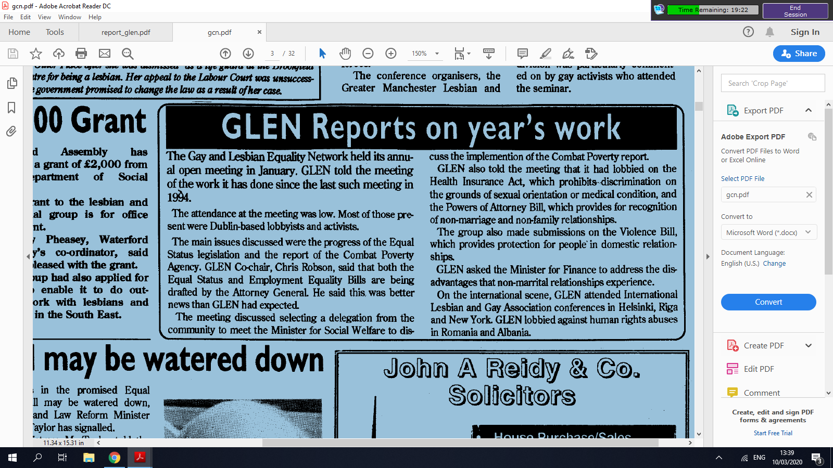

END

See Fergus Ryan, Civil Partnership and Certain Rights and Obligations of Cohabitants Act 2010 (2011)
See Richard Dunphy (1997) Sexual identities, national identities: The politics of gay law reform in the republic of Ireland, Contemporary Politics, 3:3, 247-265
On 3 April 2006, then Taoiseach Bertie Ahern performed the official opening of GLEN's new offices in Fumbally Court in Dublin 8. This was a moment of some historical significance as he was the first head of an Irish Government to visit an LGBT organisation. The Taoiseach also launched GLEN's five-year strategic plan entitled "Building Sustainable Change" which set out the priorities of the organisation going forward, the main one being the enactment of legislation providing for the legal recognition of same-sex relationships. In a speech to assembled guests, Mr Ahern declared that "Sexual orientation cannot, and must not, be the basis of a second-class citizenship. Our laws have changed, and will continue to change, to reflect this principle."^{[4]}
See Richard Dunphy (1997) Sexual identities, national identities: The politics of gay law reform in the republic of Ireland, Contemporary Politics, 3:3, 247-265
See; Education: Lesbians and Gay Men: Developing Equal Opportunities, 2000 Gay HIV Strategies and Nexus Research (2000) Education: Lesbians and Gay Men: Developing Equal Opportunities, Gay HIV Strategies, Dublin
‘According to Niamh Breathnach, then Labour Party spokesperson on equality issues, it was proposals made by GLEN that led to the Labour Party’s Equal Status Private Members Bill being broadened out to include a wide range of groups vulnerable to discrimination. This inclusive approach was later adopted in subsequent Government legislation relating to employment equality and equal status.’ see Education: Lesbians and Gay Men: Developing Equal Opportunities, 2000 Gay HIV Strategies and Nexus Research (2000) Education: Lesbians and Gay Men: Developing Equal Opportunities
On 3 April 2006, then Taoiseach Bertie Ahern performed the official opening of GLEN's new offices in Fumbally Court in Dublin 8. This was a moment of some historical significance as he was the first head of an Irish Government to visit an LGBT organisation. The Taoiseach also launched GLEN's five-year strategic plan entitled "Building Sustainable Change" which set out the priorities of the organisation going forward, the main one being the enactment of legislation providing for the legal recognition of same-sex relationships. In a speech to assembled guests, Mr Ahern declared that "Sexual orientation cannot, and must not, be the basis of a second-class citizenship. Our laws have changed, and will continue to change, to reflect this principle."^{[4]}
See Fergus Ryan, Civil Partnership and Certain Rights and Obligations of Cohabitants Act 2010 (2011)
‘From Individual Protection to Recognition of Relationships? Same-Sex Couples and the Irish Experience of Sexual Orientation Law Reform’ Leo Flynn, Legal Secretary, Court of Justice of the European Communities, (see appendix)
See ‘Gay HIV Strategies and Nexus Research (2000) Education: Lesbians and Gay Men: Developing Equal Opportunities’.
see A Chronology of Key Events, GLEN Campaign for Legal Recognition of Same-sex Relationships and Families, 2009
Building Sustainable Change, GLEN Strategic Plan 2006 - 2010
Building Sustainable Change, GLEN Strategic Plan 2006 - 2010
See article by GLEN in ‘ILGA-EUROPE: EQUALITY FOR LESBIANS AND GAY MEN A relevant issue in the civil and social dialogue’ June 1998
see Fifth Periodic Report on the Work of the NESF Report 37 · June 2008
See Joan Hart/PA Consulting Evaluation of GLEN programme 2010, https://www.atlanticphilanthropies.org/research-reports/report-evaluation-building-sustainable-change-programme
See “Mental Health: Lesbians and Gay Men - Strategies to Promote the Mental Health of Lesbians and Gay Men" 2004
^{Anna} Lee, Chairperson of the Combat Poverty Agency speaking at launch of ^{Poverty: Lesbians and Gay Men}
‘Research modelled on this study is now being carried out by Foyle Friend (Derry) and Glasgow City Council.’ (1999).

