Report of evaluation of gay hiv strategies programme

draft

Brian Dillon

October 1999

introduction, background and methodology
A baseline study on HIV prevention needs within the Irish Gay community concluded that:
“There is a pressing need for a comprehensive HIV prevention strategy for the Gay community which would be based on a partnership with the statutory sector, would be realistic but appropriate to the scale of the problem and would include an integrated plan of action with goals, objectives and targets set out at a national and local level along with defined implementation and evaluation structures”.
Following on from the conclusions of this study, and consultation with the Gay and Lesbian Equality Network, the Department of Health provided funding for a two-year ‘Gay HIV Prevention Strategies’ Programme. The funding covered remuneration and administrative support for a National Strategy Development Co-ordinator who had responsibility for implementing the recommend programme of action..
Even though agreement has already been reached on the continuation of the ‘Strategies’ Programme into a second two-year period, it was seen as vital that the operation of the first phase should be fully evaluated. This report is based upon an evaluation exercise carried out over the period May to September 1999.

1.1 Evaluation Aims
The aims of the evaluation were to:
- Document outputs of the Programme.
- Assess Programme impacts, through in-depth consultation with key stakeholders, and through independent verification;
- Ascertain reasons for particular outcomes and impacts – thereby establishing lessons, in the form of obstacles to progress or in the form of examples of good practice.
- Make conclusions re future programme strategy, based upon the lessons learned, and upon the results of consultation with relevant stakeholders. Recommendations should specifically address the future of the GHS Programme itself (in terms of future aims, priorities, working structures and procedures); but also other related programmes, interventions and spheres of policy where these become relevant.

1.2 Principle Questions for the Evaluation
This evaluation set out to ascertain:
- What were the main challenges, problems and issues pertaining to the policy environment at the outset of the Programme? What characterised the main interventions in response to these issues? How might these issues and responses have changed since? The 1996 baseline study provides much of the relevant ‘pre-programme’ data, so the intention here is to document and acknowledge key changes in the past two years.
- What has characterised the HIV Strategies Programme? To establish this a ‘resource audit’ of the Programme was undertaken to determine: resources committed to specific target groups, development themes and working methods; as well as detailing operational structures and procedures.
- What have been the main project outputs (given the inputs outlined above)? These will be drawn mainly from programme reports, as well as from direct interviews with beneficiaries and participants.
- Finally, how might these activities and outputs have impacted (beyond the immediate target group) on the Gay community generally, on HIV awareness, and on broader policy? These questions formed the basis for consultation with individuals and interests beyond the immediate scope of the Programme.

Evaluation Approach and Methods
The Objectives of the Gay HIV Strategies Programme can be summarised under two interrelated goals:
- Firstly, there was the explicit intention to involve members of the Gay Community in designing and implementing appropriate and effective HIV prevention strategies. This part of the work was based very much on the principle of full participation and partnership. Its success was seen as dependent, to a large extent, upon building the capacity of the organised Gay Community to develop effective participative and partnership activities.
- On the other hand, in recognition of the fact that the Programme was also innovative, there was also the intention to contribute to the broader policy environment from the experience gained. Given the first aim as outlined, the ‘policy environment’ in this case includes policies and activities to support Gay community development, as well as policies and activities relating to health and HIV prevention.
Because of this, the evaluation exercise needed to place considerable emphasis on recording the direct experiences of key ‘stakeholders’ in the Programme – those within the Gay community; but also those representing a fairly wide range of interests within the broader ‘operational environment’.
Results contained in this report are based upon:

A Review of Baseline Issues and Policy
Using the 1996 report as a baseline, consultations took take place with:
- Department of Health and Health Board Personnel (through interview);
- Key individuals working in the HIV prevention and Gay Community Development (this took the form of a structured workshop involving members of the HIV Strategies Board and other invited individuals).
Feedback from these allowed for the establishment of key trends and policy developments over the life-span of the Programme to date – as well as imminent or planned policy and initiatives. These initial consultations also allowed for clarification of the evaluation methodology, and inputs from key stakeholders into the process. It was especially useful in eliciting opinions on appropriate output and impact indicators for the Programme’s performance. In addition to consultations, some review of relevant literature was also undertaken during this Phase.

Programme ‘Resource Audit’
A comprehensive audit of key programme inputs and outputs was then undertaken. This was carried out in close consultation with the Programme Coordinator and relied mainly on existing documentation. The recording mechanism was designed with an internal evaluation function in mind – in other words, it is foreseen that the same framework can be used during subsequent phases of the Programme. With this in mind, the incoming Programme Co-ordinator (as well as the outgoing one) was consulted. The framework developed from this process is being proposed as the basis for future phases of programme implementation and monitoring.
A review of programme inputs and outputs (from Programme reports, associated documentation and some consultation with central stakeholders) allowed for the development of output and impact indicators. These then became the focus for subsequent consultation with wider stakeholders (see below).

Consultation with Stakeholders
This phase of the evaluation involved a survey of programme beneficiaries, managers, participants and ‘target groups’ to complete the ‘outputs’ picture. Furthermore, it allowed for the exploration of broader impacts with these respondents. In other words, what were the effects of the Programme, if any, beyond the immediate assistance, support or contact provided? Feedback on this was obtained from the following:
- Department of Health and Eastern Health Board Personnel, including Social Work services;
- Gay organisations, groups or services who have had an ongoing association with the Programme. These included Boilerhouse (Sauna), Outhouse, Parents’ Support Organisation, Gay Community News, Gay Switchboard Dublin, Gay Mens’ Health Project, Gay and Lesbian Equality Network, individual Gay Community Workers.
- Other stakeholders who have contributed to, or benefited from, the programme – for example an Garda Siochana, Community Workers Cooperative, Lesbian Education and Awareness project (LEA), Womens Education Research and Resource Centre.
As well as establishing outputs and impacts, significant emphasis was placed on exploring perceived reasons for these with respondents.

Consultation with Members of Gay HIV Strategies Board of Management
Current and past members of the Board of Management were also consulted (through a dedicated meeting and questionnaire survey) to ascertain their views on:
- Representation of appropriate expertise and interests;
- ‘Turnover’ or cycle of representation;
- Assistance or Supports to decision-making;
- ‘Distribution of decision-making – at Board and sub-Board levels;
- Participation and contribution to discussion by Board members.
Under each of these headings, current and previous Board members were asked to identify factors that have assisted progress, factors that have hindered or blocked progress, and outstanding needs for the next planning period.

Exploration of Strategic Proposals with Key Stakeholders
Preliminary conclusions were presented to members of the Programme Board (and to other invited parties) at an evaluation workshop to discuss the implications of evaluation findings. The workshop helped to frame proposals for future strategy, based on evaluation conclusions, elements of good practice and barriers to progress (where identified).
The final stage of the evaluation then allowed for a further round of consultation with particular stakeholders on possible future strategies. The intention here was to explore, in a very practical way, the potential and limitations associated with particular avenues for building upon the achievements of the Programme to date. Respondents at this final stage included:
- Statutory personnel in Health, Social Welfare and possibly Education;XXX
- ADM Ltd.XXX
- The Combat Poverty Agency.XXX
- Key groups and interests in the voluntary and community sectors.XXX
ALL TO BE AGREED

Review of the Programme’s ‘operational environment’ at the Outset
A number of key factors were acknowledged (again in the 1996 research process) to have been important in justifying and facilitating the establishment of the Gay HIV Strategies Programme. It is important that this broader operational and policy environment is reaffirmed here as the starting point for programme evaluation because:
- On the one hand, existing institutional, policy and organisational very much define both opportunities and constraints in relation to programme activities. This provides a base-line position whereby realistic expectations about potential achievements can be formulated, and progress subsequently evaluated.
- On the other hand, a substantive part of the Gay HIV Strategies Programme was about influencing elements of this ‘operational environment’. Part of the Programme brief was to ‘develop a national sectoral … approach to building effective gay health strategies into more mainstream development activities.’ It should therefore be expected that the evaluation process would point to ways in which the Programme has impacted upon its operational environment (as well as being influenced and constrained by it).
The operational environment at Programme set-up stage was critically defined through:
- The level of exposure to the AIDS virus amongst Irish gay men. About 7.5% of gay men testing in Ireland were testing positive, and numbers were on the increase. It was estimated in 1996 that more than two thousand gay and bisexual men were HIV positive.
If this constituted the major threat or challenge, then other developments had thrown up new opportunities to respond. For example:
- Important developments in the Irish legislative environment as far as the gay community was concerned - brought about by the granting of full legal equality to gay people in the law reform of 1993. Related anti-discrimination legislation had been implemented, or was being prepared.
- In the field of sexual health and HIV prevention, the wider legal availability of condoms.
- More general developments in the public policy and service delivery environment: notably an increasing tendency towards partnership with the voluntary sector as a valid and effective mechanism for intervention on a range of development issues – but particularly in relation to social exclusion.
- The translation of these more general trends into specific strategic priorities in the areas of healthcare and health promotion in Ireland. A Department of Heath report in 1994 had emphasised the importance of the voluntary sector role in service development and delivery:
“Traditionally, voluntary organisations have been to the forefront in identifying needs in the community and developing responses to them. Their independence enables them to harness community support and to complement the statutory services in an innovative and flexible manner”
Furthermore, the Health Promotion Strategy (published the following year) was founded on a number of prerequisites. These included:
- The creation of a supportive environment
- The strengthening of community action
- The involvement of professional organisations and self-help mutual aid groups in health promotion.
Taken together, these developments provided both the context and rationale for the establishment of the GHIVS Programme – in that it represented both an attempt to strengthen ‘community action’ in the context of the gay community; and an attempt to positively influence mainstream service provision through building a working partnership.
Important changes and further developments have taken place in the operational environment since 1996. These are examined in later Sections of the report, in the sense that they:
- Can be seen as areas of impact of the Programme itself: in other words, how the Programme has succeeded in influencing its broader operational environment. This is assessed for various programme actions and activities throughout the report.
- Provide the backdrop for future development of the Programme. An ‘audit’ of the current operational environment is contained in the final Section of the report, as a prerequisite to recommending future goals and targets for the Programme.

3. historical evolution of Programme Activities and management
The Programme was officially established in June 1997. This Section of the report summarises its principal areas of work between then and September 1999; as well as the organisational and management arrangements established.

Summary of Programme Activities
The Diagram below summarises the overall goal and two strategic arms of the Programme.
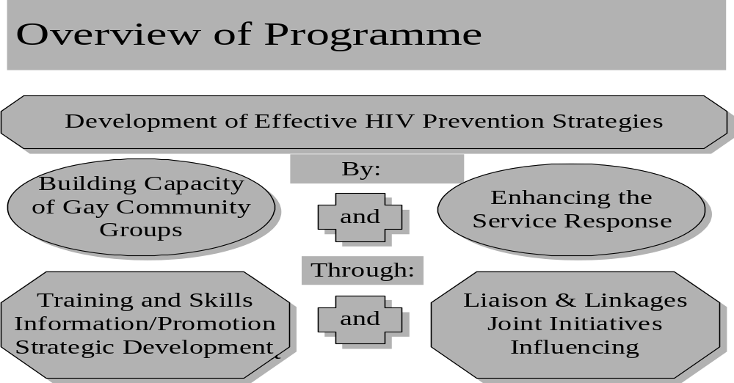

3.1.1 Building Capacity of Gay Community: Summary of Actions
Activities initiated under this broad objective can be summarised under the following headings:
- Training and personal development initiatives, aimed at increasing the capacity of gay men (in specific contexts) to become more proactive in the context of HIV prevention.
- Actions designed to increase the capacity of particular organisations to produce and disseminate information, promoting safer sex and developing co-operation amongst a range of actors relevant to HIV prevention.
- Direct support for gay organisations in strategic development:. This included facilitation and assistance with needs assessment, funding proposals and liaison with statutory and other agencies.

Training and Skills Development
Two training initiatives were implemented:
- The first, and the most significantly in resource terms, was the development and implementation of HIV Prevention training with the Gay Sauna sector. This was initiated with the dual aim of increasing capacity of Gay commercial operators (Dublin Saunas) to proactively promote safer sex practices amongst their clientele, while at the same time developing formal lines of cooperation with the statutory sector. Staff from two Gay Saunas were facilitated within a process that enhanced their individual skills in ‘informing, responding and supporting customers re safer sex’.
- The second training initiative (organised through Gay Switchboard Dublin and held in Outhouse) consisted of an “Assertiveness Course” for Gay men. This aimed to increase capacity, at an individual level, to negotiate safer sex practices.
The possibility of running a further training initiative was actively pursued with the PAUL Partnership in Limerick. The intention was initiate a training programme for volunteers, but the idea was not pursued.

Production and Dissemination of Information
Actions undertaken in this field involved a fairly wide spread of Gay community groups and organisations, and covered a range of approaches to both the production and dissemination of information. They comprised the following:
- The initiation of a pilot project in partnership with ‘Parents’ Support’, involving the production and distribution of booklets and leaflets. The action was intended to contribute to the creation of a more informed response amongst parents re HIV and related issues; and, by extension, the empowerment of younger gay men through parental knowledge.
- The development of a safer sex promotion strategy with the Gay sauna sector. Very much linked in with the Sauna training (noted above), this represented an attempt to develop new and effective means of building awareness re HIV amongst Sauna users. It was undertaken in partnership with the management of two saunas, and resulted in the production and distribution of a range of written and visual materials; together with the distribution of condoms and lubricants.
- The development of pilot projects in partnership with Gay Community News (GCN). The aim in this case was to upgrade coverage of HIV and related issues; and to help develop new, more effective and more targeted ways of distributing GCN.
- Support for the publication of the ‘POZ Ireland’ Bulletin, with the intention of enhancing the quality of information relevant to people who are HIV Positive; improving dissemination strategy; and strengthening linkages with statutory service providers.
- Supply of equipment (VCR and television) to Outhouse, for use in promoting discussion around HIV prevention and related issues.
- Support for the production and dissemination of information materials by the Gay Health Network. This comprised a series of targeted leaflets covering a range of topics including testing procedures and safer sex advice.
- Participation in the EU-funded DAPHNE Project, resulting in the production of an Irish national report addressing the issue of violence against gay youth. The report was produced and disseminated jointly by Gay HIV Strategies and Gay Switchboard Dublin. The European project also incorporated partners from Finland and Italy.

Support for Gay Community Organisations in Strategic Development
In addition to specific training and information-related activities, the Programme also provided support to a number of organisations and groups in the context of their more general strategic development. This support involved:
- A ‘Youth Pilot Project’ carried out in partnership with Gay Switchboard Dublin. The objective here was to work towards ‘developing and strengthening OutYouth as a sustainable service’. With Eastern Health Board support, a ‘needs and resources analysis’ of the group was carried out. Following on from this analysis, Gay HIV Strategies worked with OutYouth to identify possible sources of funding to assist with the group’s future development. There were also attempts to develop and sustain links with mainstream service providers and youth development agencies.
- Work with the management of two gay saunas, with the intention of ‘developing collaborative and sustainable models of HIV prevention’. This involved facilitation of sauna management in planning and reviewing their overall approach to prevention (including training and information-related actions also facilitated by the strategies programme). A report of this process was produced.
- Capacity-building and facilitation of strategic development with gay and lesbian community in Waterford City. A needs assessment was carried out (based upon direct consultation with members of the community); a strategic plan for future development was agreed and published; future funding possibilities were identified and pursued; and capacity-building measures were carried out (including personal development training).
- Work with the Southern Gay Health Project (based in Cork City) to design and implement a regionally-based HIV prevention strategy. The intention was to facilitate the first steps in the development of a working partnership between the Gay community and Southern Health Board (drawing upon lessons and experiences from the partnership between the Eastern Health Board and the Gay HIV Strategies Programme). Consultation with a range of gay community organisations and services was carried out; and proposals for a regional prevention strategy were drawn up.
- Liaison with gay community organisations in Limerick City, and with representatives of the South Western Health Board, with a view to exploring the potential for joint initiatives. A funding proposal, identifying a range of developmental activities, was produced.

3.1.2 Enhancement of the Service Response: Summary of Actions
A further set of activities were aimed at contributing to and influencing the ‘broader policy environment’. The intention was to build stronger and more collaborative links between the gay community and a range of service-providers and development agents within the statutory and wider community/voluntary sectors. This could establish channels through which lessons from the pilot programme could be carried through to mainstream policy and practice; but it could also lay the foundations for building more lasting partnerships between mainstream services/development agencies and the gay community.
In summarising these activities below, a distinction is made between:
- Ongoing liaison and linkages with particular agencies and programmes – typified either by cooperation in the implementation of particular initiatives, or by ongoing reporting and exchange of information.
- Cases where this kind of liaison and linkage actually progressed into joint activities. This is where the Gay HIV Strategies Programme worked in partnership with more mainstream service-providers and development agents to implement new initiatives.
- Contributions from the Strategies Programme to the wider policy debate. These took the form of submissions, position papers, contributions to seminars, conferences etc – intended as a way of communicating experiences and activities within the Programme; and of interpreting these experiences in the context of mainstream policies and actions.

Ongoing Liaison and Linkages
The Strategies Programme was involved in:
- Ongoing liaison, negotiation and cooperation with Eastern Health Board personnel to define, select and implement pilot capacity-building programmes with gay community organisations in the EHB region.
- Further liaison with the Eastern Health Board within the context of wider service delivery. This included initial contacts with the Programme Manager responsible for Childcare Services, and subsequent introductory investigation of the role and potential of EHB childcare services in relation to HIV prevention and the gay community.
- The development of a working relationship with the National Youth Federation (NYF); resulting in a conference, organised by the Federation, on the needs of gay and lesbian youth.
- Meetings with City of Dublin Youth Services Board (CDYSB). These allowed for discussion on mainstreaming gay youth issues into the work of the Board; and on funding possibilities for the OutYouth group.
- Meetings with the Youth Affairs Section of the Department of Education, focussing on developing a funding application for the employment of youth workers.
- Development of links with the Youth Health Programme. Discussions took place, over a series of meetings, about curriculum development regarding training for youth workers on gay issues.
- Development of links with the Midland Health Board Health Promotion Service; discussions (linked to Youth Health Programme contacts above) led to two training sessions for youth workers in MHB region.
- Development of linkages with North-Western Health Board; resulting in preparation of funding application for regional gay HIV prevention strategy.
- Liaison with Health Promotion Unit (Department of Health): taking the form of meetings and participation by the Programme in a conference on HIV/AIDS organised by the Unit.
- Ongoing linkages and liaison with an Garda Siochana. This resulted in a meeting between the Chief Superintendent and a number of gay community groups; as well as an input by Gay HIV Strategies into national Garda policy on gay and lesbian issues.

Planning and Implementing Joint Initiatives
In six cases, external liaison actually led to the development and implementation of new activities during the first Phase of the Programme, establishing a working partnership between Gay HIV Strategies and other agencies. These were:
- Most significantly, the Eastern Health Board, in defining and implementing pilot projects. The process of pilot-programme definition and selection began with a series of consultation meetings between gay organisations/services and EHB Programme manager. Following on from project approval, a continuous reporting system between the Strategies Programme and the EHB was initiated; and there was ongoing joint consultation in the subsequent delivery of technical assistance to approved groups, within the context of Health Board Policy.
- Two initiatives planned and implemented in partnership with the National Social Services Board (NSSB). The first a paper and computer-based information pack disseminated to NSSB information centres (in association with LEA and Gay Switchboard Dublin); the second a jointly produced poster, funded by the NSSB and disseminated by a range of gay groups and organisations participating in the Gay HIV Strategies Programme.
- The development, with Waterford Area Partnership, of a strategy designed to support capacity-building of the gay community; and to increase the accessibility of statutory and community/voluntary service provision and interventions.
- The distribution, in association with the Department of Education, of information materials (produced by the Gay HIV Strategies Programme) to Youth Information Centres in various parts of the country;
- The production of an Irish national report on Gay AIDS Prevention, as a result of the Programme’s participation in the European Gay AIDS Prevention Network. The network involved gay organisations from twelve EU Member States, and also resulted in the production of proposals to initiate a transnational gay sauna project.
- Carrying out research into the nature and extent of educational disadvantage amongst lesbians and gay men (funded through private donation).

Gay HIV Strategies Programme Contribution to the Wider Policy Debate
A full list of reports/publications/papers produced through the Programme is appended as Annex 1 to this report. Some of the more significant of these were:
- Publication of policy paper on HIV Prevention and Gay Youth – in the National Youth Federation Journal.
- Paper on Gay Mens’ Health produced and delivered at national mens health conference.
- Contribution on Irish experience as part of EU CERIS Programme. This arose from a conference (European Congress on Identity Risks and AIDS) dealing with the vulnerability of young gay men to AIDS. The Gay HIV Strategies Programme made a presentation to the original congress, which has subsequently developed into a 13-member project to develop European-level strategies and campaigns to tackle the particular vulnerability of young gay men to HIV and AIDS.
- A range of submissions, articles, meetings and papers on the subject of social exclusion and the gay community. These included: submission to Green Paper on the future of the Community and Voluntary Sectors; submission to the Strategic Plan of the Combat Poverty Agency; a paper on local development and the gay community, published by the Community Workers Cooperative; article on the work of the Gay HIV Strategies Programme published in Poverty Today Magazine; meetings with individuals with responsibility for local and community development, including with the Combat Poverty Agency and Area Development Management Ltd (ADM).
- A similar range of interventions on legal, justice and equality issues. These included submission to Department of Justice Equality and Law Reform on sexual offences; submission to Juvenile Justice Working Group (in DJELR) and participation in Seminar organised by the Group; submission to National Crime Forum re anti-gay violence, as well as briefing to a public session of the Forum.
- Contributions to the preparation of Departmental Customer Action Plan (Department of Health); Strategic Management Initiative (through SMI interdepartmental Committee); and the National Anti-Poverty Strategy (through the NAPS Unit).
- Contributions to, and participation on, the National AIDS Strategy Committee and the Educational sub-committee. Progress reports from the Gay HIV Strategies Programme were prepared and presented in each case.

Resources, Management and Organisation

3.2.1 Financial Resources
The Programme was core-funded by the Department of Health, through a grant of £50,000 per annum (a total of £100,000 up until June 1999). This allowed for the employment of a full-time Director and the establishment of an office.
The Gay HIV Strategies Programme subsequently secured support from the Eastern Health Board to fund pilot projects in their region. A total of £50,000 was made available for this process; and the allocation of these resources for 1998 was as follows:
Summary of Allocation of Resources to EHB Pilot Projects for 1998
Project | 1998 Allocation
Gay Switchboard Dublin (OutYouth capacity building, strategic development and evaluation) | £9,550
Gay Community News (training, distribution and promotional strategy) | £9,500
Gay Health Network (Printing, publicity, research and evaluation) | £10,664
Gay POZ (publication, distribution, technical assistance, equipment) | £8,700
Gay HIV Strategies (Prevention strategy and programme of action for Saunas) | £3,485
Outhouse (Education equipment grant) | £1,761
Parents Support (Booklet and Leaflets) | £1,900

Work of the Director
The Director was solely responsible for implementation and coordination of actions under both ‘strategic headings’. That is:
- Building the capacity of gay organisations to design and implement effective HIV prevention strategies.
- Contributing to mainstream service development and policy formulation.
In addition, the Director was responsible for the production of ongoing progress reports (to Gay HIV Strategies Board, Department of Health and Eastern Health Board); and for ongoing programme ‘maintenance’, including planning and review meetings, supervision of finances, seeking additional resources etc.
In other words the Director’s time (the programme’s principal resource) was divided between the achievement of external objectives and maintenance of internal programme infrastructure. An audit of this time commitment, illustrated below, shows that internal ‘set-up’ work took up most time during the first quarter of the Programme; and, subsequently, typically took up between 20% and 25% of time.
This effectively meant that the Programme was implemented (in terms of pursuing ‘external objectives’) through 75% of Director time.
Contribution of Director’s Time to the Achievement of External Objectives and to Programme ‘Maintenance’ Over Phase One
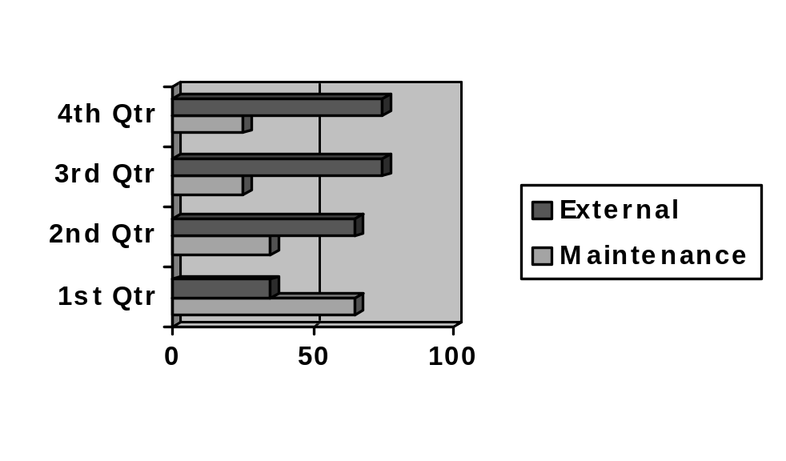The Chart below further shows that, in programme implementation, resources were directed fairly equally between the two ‘strategic arms’. However, increased time was spent on service-enhancement activities during the fist and final quarter.
Division of Director’s Time Input into Both Aspects of the Strategy
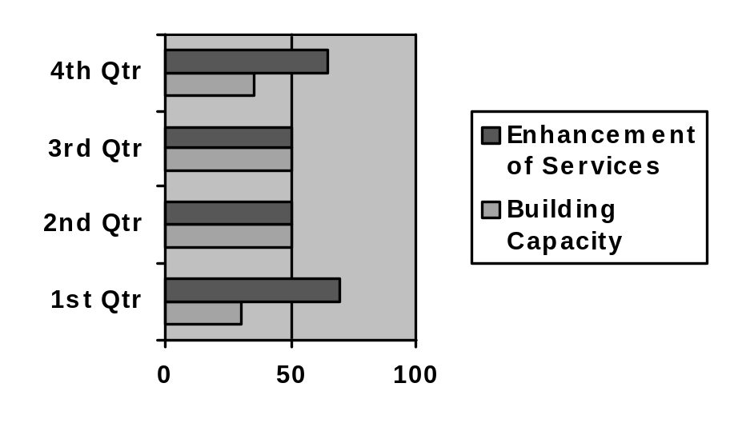These fluctuations in time commitment were linked to specific developments within the broader policy environment. For example, requests to make particular submissions or presentations were normally linked to a particular time-frame, and had to be responded to within that time-frame.

3.2.3 Role and Composition of Board
The intention at the outset (again envisaged in the 1996 report) was to ensure a spread of experience and expertise at Board level that was appropriate to and consistent with the development objectives of the programme. Board members, who met xxx times during the course of the pilot phase, were representative of experience and expertise in:
- Health and social service development and delivery (Psychiatric and Social Work Services);
- Gay community development (in Cork, Waterford and Dublin);
- Research and policy development (in the field of gay community development and social exclusion generally);
- Community and voluntary sector development (through the Chairperson of the national Anti-Poverty Network, the Director of a Dublin inner-city community-based project working with drug-users and their families, and a Director of Youth Services at regional level).
Numbers active at Board level remained fairly constant (there are currently 8 members); although there were replacements as the pilot phase progressed. Replacements were generally drawn from those areas in which the Strategies Programme was active (either geographically or in a thematic sense). Examples of this are the two most recently appointed Board members: one who was centrally involved in the Programme’s work in Waterford; and the other had been consulted in the preparation of several submissions and position papers within the field of community development and social exclusion.
Board meetings normally took the form of reviewing progress (informed by progress reports from the Director); discussing the implications of this; and taking decisions on the focus of work for the next planning period. Some Board members also represented the Programme: communicating Programme experiences either in Ireland or abroad; or reviewing progress with Programme sponsors (meetings with Department of Health and Eastern Health Board personnel).

4. Programme Outputs and at Project Level
This Section of the report contains a summary of Programme outputs (verifiable direct outcomes from actions carried out) A discussion of the Programme’s overall impact (the effect of these outputs in the context of broader Programme objectives) is contained in Section 5.

4.1 Summary of Outputs
Before going on to evaluate Programme impact in a cumulative sense, it is first important to identify the actual outcome of specific actions undertaken. In other words, what were the immediate results of the activities described in Section 3?

4.1.1 Outputs From Capacity-Building Work with Gay Community Organisations
As outlined in Section 3, the main organisations in question here are Gay Switchboard Dublin; Gay Community News; Outhouse; Parents’ Support; Gay Saunas (principally Boilerhouse); POZ Ireland; Waterford Gay Group; Gay Health Network; and the Southern Gay Health Project. Output indicators (in terms of capacity-building) are considered for each of these groups in turn below. Information is drawn, in each case, from both direct interviews from representatives of the group/organisation and/or from written documentation.

Gay Switchboard Dublin
Gay Switchboard Dublin’s principal associations with the Programme were through:
- The Youth Pilot Project with OutYouth;
- An assertiveness course for Gay men;
- The EU DAPHNE Programme
Outputs can be summarised as:
- The participation of 40 young people in the capacity-building programme;
- The production of report on capacity-building programme, and strategic plan for OutYouth;
- The fact that some 40 young people are now participating in the Youth Project on a weekly basis;
- Expansion of the leadership base within the core of volunteers in OutYouth;
- The participation of 18 men in assertiveness training (demand for this kind of training was demonstrated by the fact that 27 people applied, without active promotion of the initiative by the sponsors);
- The production of an internal evaluation, based upon the experiences of participants in assertiveness training;
- Production of a national report on violence against gay youth;
- Participation in, and contribution to, two international conferences
GSD themselves attach significant importance to progress made in building their own capacity as a result of participation in the Gay HIV Strategies Programme. Particular significance is attached to the ongoing development of OutYouth; although there is an apprehension about this progress being reversed if a commitment to ongoing and consistent funding is not secured.
In overall terms GSD identified the ‘space to plan more proactively’ as the most important determinant of success. According to the Director, many of the ideas they are now pursuing were probably ‘on the agenda already’. Gay HIV Strategies support and involvement was crucial in that it allowed them space to pursue some of these ideas, produce visible results, and thus instil confidence to take on other challenges. Participation in the EHB pilot project process was also seen as important: in the sense that it allowed the Switchboard to interact directly and purposefully with other gay community organisations and with the Health Board. Raising the profile in this way, according to GSD, has led to more people being willing to become involved as volunteers in delivering the service. For example, they point to the fact that 14 ‘high-quality’ people took part in their latest training intake.

Gay Community News
GCN’s principal connection with the Programme was through the EHB-supported pilot project – designed to upgrade HIV coverage in their Newspaper, and to enhance their distribution and dissemination capacity. The project resulted directly in:
- Enhancing awareness and expertise on HIV prevention; especially relevant through an increase in editorial capacity to cover HIV-related issues;
- Changes in format, whereby xxx;
- New outlets for the Newspaper;

Outhouse
The original plan was for Outhouse to participate at two levels:
- Firstly, with a view to increasing their referral capacity and procedures, Outhouse proposed that assistance should be given to undertake a needs assessment and to review their current linkages with statutory and other significant service-providers;
- Secondly, it was also proposed that communication equipment be supplied through the programme (in effect a television and VCR) to assist with efforts to build awareness around HIV-related issues amongst the users of Outhouse facilities.
Only one of these proposals (the second) was pursued in the end. This was due to the first proposal being reconsidered by Outhouse, resulting in a decision to negotiate an alternative proposal with the Eastern Health Board.
Despite this, there is an acknowledgement from Outhouse of positive outcomes from their involvement in the Programme:
- In the first place, despite the relatively small amount of resources associated with it, the value of access to communication equipment is not underestimated. The point being made here is that, while it may be possible to secure such funding elsewhere, it is not easy to secure it in a way that maintains organisational discretion around its usage. The acknowledged benefit for them in this case, was the capacity to implement their own plans around awareness-building using the equipment.
- Secondly, there is also an acknowledgement of the importance of participation in the EHB pilot-project definitional process. As a much ‘younger’ organisation than most other participants, Outhouse particularly benefited from the opportunity to ‘plug into the other organisations and networks’ – thus enhancing their capacity for effective referral. Increases in referrals signifies a two-way process in this case – in other words referrals by Outhouse (mainly to health service providers); and referrals to Outhouse (mainly from Eastern Health Board Social Work services).
- Thirdly, the organisation also attaches importance to ongoing contact with the EHB; principally because of the sense of ‘legitimacy’ it brings with it.

Parents Support
The one pilot project in which Parents Support participated led to:
- The distribution of 825 leaflets and 401 booklets providing information to families and friends of young gay people. This included dissemination to groups in the North of Ireland, as well a substantial number distributed through the NSSB Information Centre system.
- An increase in their own capacity as an organisation – to the extent that numbers actively involved in their committee increased from three to nine people during their time of involvement with the Programme.
- Increased numbers of contacts with, and enquiries to, the organisation as a result of the leaflet and brochure campaign. This included an increase in requests from media sources (mainly national radio) to make contributions on gay and lesbian issues.
In acknowledging a very significant benefit to their organisation, Parents’ Support attach considerable importance to:
- Participation in the EHB pilot project definitional process, providing as it did the opportunity to establish contacts and working relationships with a range of gay organisations and service providers. The opportunity to establish a working relationship with a statutory agency, through this process, was also seen as beneficial to enhancing their own capacity
- The need for continuity and security about future development. Delays and uncertainty about future support have the potential to slow down, or even reverse, their growth.

Gay Saunas
Four gay mens’ saunas in Dublin were encouraged to participate in actions that would assist them in developing ‘collaborative and sustainable models’ of HIV prevention’, mainly through staff training and involvement in a safer sex promotion strategy. Specific outputs of this were:
- The production of a discussion paper, based on consultation with sauna management, that formed the basis for development and refinement of the overall strategy;
- The participation in training (developing skills around informing, responding to, and supporting customers in safer sex practices) Training was delivered in partnership with XXX.
- The production of posters and leaflets, many of which were designed ‘in-house’ using material downloaded from the web.
- Distribution of these as well as condoms and lubricants. Condoms and lubricants were placed in lockers along with towels at each ‘change-over’; steriliser units were introduced to sterilise locker key wrist-bands after each use; aftershave dispensers were installed and sterilising wipes for seats were installed in the toilets; comment and suggestion boxes were placed in the entrance and exit areas.
- Public dissemination of results. This included: the production of a report, explaining the model developed, the lessons arising, and making recommendations with regard to mainstreaming; as well as an article in Gay Community News.
Participation in the overall strategy was more active and comprehensive for one sauna (‘Boilerhouse’) than for the remainder. In this case, management of the sauna point to:
- A ‘transformation’ in the way safer sex practices are communicated and understood. Particular significance is attached to the change away from ‘talking at people’ and towards developing communication materials and methods that are participative, non-judgemental and positive.
- The importance of building up trust, especially in the initial stages of strategic development, if such a positive approach is to be successfully implemented. The employment by the HIV Strategies Programme of an outreach worker to negotiate and consult on an ongoing basis was an essential element in this.
- Very definite improvements in the capacity and confidence of workers (who had participated in the training sessions) to communicate re safer sex practices amongst their clients; and to provide information to them on the availability of other services (especially testing services).
- The importance of ongoing contact with statutory service-providers (mainly through the strategic planning process and the training). This has given them the sense that they are maintaining an ongoing commitment to effective HIV prevention work with gay men; and it has also led to ‘more confidence’ in referring clients on to mainstream services where necessary or appropriate.

POZ Ireland
Support for the publication of POZ Ireland, through the Strategies Programme led to:
- The production of XX issues of the newsletter dedicated to medical and service-provision issues on HIV/AIDS (supported through the EHB pilot project process).
- The establishment of an editorial board to enhance and improve coverage of these issues.
- Improvements in distribution of the newsletter (including targeted distribution using e-mail).

Gay Health Network
Specific outputs for GHN were around:
- Printing and publicity of HIV testing leaflet and Safer Sex Card;
- Printing and publicity of Living with HIV leaflet and Treatment Options leaflet.
- .Research Project???
- Evaluation???

Waterford Area Partnership Capacity-Building Project
Needs assessment and capacity-building work with gay people in Waterford City led to:
- The establishment of a Resource Group to support future local initiatives. As well as gay and lesbian representatives, the group includes the Director of Waterford Regional Youth Services and the Community Development Worker of Waterford City Partnership.
- Organisation of a recreational and developmental weekend, organised by Waterford Regional Youth Services.
- Dedication of local Youth Worker time to support and facilitation of gay youth development.
- Person meeting with Minister of State Flood concerning possibilities for mainstreaming of results – within both the Local Development Programme and in other national and EU programme areas. The latter included a submission regarding inclusion of lesbians and gay men as a named group in the forthcoming EQUAL Programme.
- The production and launch (by the Minister of State with responsibility for Local Development) of a report on the process and lessons emerging.
- Submission of a proposal and ongoing discussion with the Department of Social Community and Family Affairs regarding future support for the initiative.
- A gay community photographic exhibition, held in the Garter Lane Art Gallery with support from Waterford Corporation.
Activities in Waterford are significant to the extent that:
- Awareness has been raised at a general level; but also more specific awareness of the links between gay/lesbianism and social exclusion. This has been carried forward into the operational and policy positions of at least some local agencies. These include the local partnership and the local Youth Services.
- The project is a good example of where both arms of the Gay HIV Strategies approach were incorporated in a single initiative. The significance and implications of this is explored in more detail in Section 5 (impacts).

Southern Gay Health Network
Gay HIV Strategies assisted with the facilitation of a consultation process (centred in the Cork City area) aimed at identifying content and funding possibilities for a structured HIV Prevention Programme for the Southern region. The Southern Gay Health Network committed some of their own resources to development of the proposal (with the help of a consultant). While the process is still effectively at proposal stage, it has allowed for:
- A debate amongst gay organisations and service providers in Cork about the need for such an initiative.
- Ongoing dialogue with the Gay HIV Strategies Programme (and initial contact with statutory agencies) about the possibility of establishing a project – drawing upon the lessons of the existing Strategies Programme.

4.1.2 Outputs From Work Aimed at Enhancing and Influencing Mainstream Service Delivery and Policy
It is clear from the previous Section that the process or methods employed are of critical importance to the outcome. In other words, outputs in terms of building organisational capacity are very much dependent upon the extent to which groups and individuals are able to participate in and understand the process.
The ultimate test of achievement in terms of service or policy influence, however, it the extent to which suggestions, proposals, activities, are taken on board as part of the ongoing operation of specific agencies. This is discussed in more detail in Section 5 (‘Impacts’). The sub-sections below first summarise the outputs – detailing which methods were used, and where the emphasis has been. The Table below provides an overview of this.

Overview of Development Themes and Methods of Influence
Development Focus | Ongoing Liaison and Linkages | Joint Initiatives | Influencing Policy and Practice
Health | - Dept. of Health, Dept. of Health Youth Programme, Dept. of Health HPU, EHB, EHB Childcare Services, NWHB, MHB, National AIDS Strategy Committee | - EHB Pilot Projects  - EU GAP Project, | - Paper to national Mens’ Health Conference  - Position Papers on Dept. of Health Customer Action Plan
Education | - Youth Affairs Section (Dept of Education), | - Research supported by private sector
Information Provision | - NSSB | - NSSB poster dissemination  - NSSB Information Package
Justice | - An Garda Siochana Chief Superintendent |  | - Submission to National Crime Forum re violence and press releases  - Briefing to Crime Forum  - Submission re Human Rights Commission  - Submission to Juvenile Justice Working Group
Youth | - CDYSB, National Youth Federation, Youth Health Programme, Finglas Youth Services, Waterford Regional Youth Services | - CDYSB Youth Information Centres, EU DAPHNE and CERIS Projects | - Policy Paper in NYF Journal
Community Development | - Community Workers Cooperative  - Combat Poverty Agency  - Area Development Management | - Waterford Partnership Resource Group | - Submissions to CPA Strategic Plan, Green Paper on Community and Voluntary Sector,  - Local Development Policy Paper published by Community Workers Coop  - Article in ‘Poverty Today’ magazine  - Submission to National Anti-Poverty Strategy

In summary:
- In terms of maintaining ongoing contact and liaison (through meetings and progress reporting) most outputs were in the area of health; although issues pertaining to youth and community development were also significant in this respect.
- Joint initiatives - involving actual resources being committed by external partners to new projects – resulted in all the development themes pursued, with the exception of Justice and Equality.
- In terms of an ongoing influence on policy and service delivery, most outputs were in the fields of community development and justice/equality; this is not surprising, given the fact that fundamental policy review was ongoing within these areas during the time in question

4.1.3 Summary of Overall Outputs and Areas of Impact
Bearing in mind the overall level of resources committed and the short period of time involved, the breadth and depth of programme outputs is extremely impressive; including as they do:
- Verifiable and acknowledged increase in the capacity of six existing gay community organisations (both voluntary and commercial).
- The establishment of ongoing formal relationships, and potential future funding possibilities, between the gay community and the statutory sector (most notably through the Eastern Health Board pilot projects).
- The development of new, and more inclusive, methods of information production and dissemination in three cases (but most notably in the gay sauna sector).
- The dissemination and publicising of lessons from these experiences; not only in Ireland but also through three EU-supported initiatives.
- The stimulation of new initiatives which, taken together, have generated new resource commitments more significant than the Programme’s core funding.
The significance of these outputs – in terms of overall Programme impact – is discussed in the next Section

Cumulative Impacts at Programme Level
This Section of the report draws together evaluation results from both aspects of the Gay HIV Strategies Programme and includes:
- A set of indicators, designed to test the extent to which the Programme has achieved its objectives in the overall sense; and an attempt to apply these indicators – drawing upon evidence of actual outcomes, and upon direct feedback from people consulted during the course of the evaluation.
- Some analysis of those factors that helped or facilitated positive impacts; as well as those factors that blocked, or acted as barriers to, success. This relies totally upon feedback from the consultation process, and includes factors associated with programme management and organisation.

5.1 Applying Impact Indicators
Specific impact indicators were not agreed and put in place at the beginning of the Programme. During the early stages of the evaluation process, however, discussion with some of the more central stakeholders in the process (including the Department of Health and participant organisations) involved some exploration of original expectations. Based on this, the following are presented as ‘working indicators’ by which overall programme impact can be discussed. These are presented under three headings, in the sense that:
- Indicators are needed to make some judgement upon the Programme’s contribution to ‘building the capacity of gay community organisations’;
- Others are needed to assess the extent to which the Programme has impacted upon more mainstream service delivery practice and policy; but
- A further set of indicators are needed to measure the relationship between these two areas of activity. These help to measure, for example, the extent to which ‘building gay community capacity’ has itself impacted upon policy. Conversely, they also help to establish whether, and how, more mainstream policy work or influence has contributed to community capacity building.

5.1.1 Indicators to Establish Programme Impact on Capacity of Gay Community Organisations
It the Programme were to fully meet its first major objective, it should be expected that:

Firstly, participant groups would have increased awareness and core competencies around HIV prevention.
This was most evident in the case of:
- The Boilerhouse and XX saunas, where skills of staff in communication and referral were upgraded, and new procedures re safe sex were introduced.
- Both POZ Ireland and Gay Community News enhanced core competencies at editorial level.

Secondly, participant groups should have increased their capacity to link in with other activities, services and organisations
This was evident in the case of:
- Outhouse, principally through the EHB pilot project definitional process.
- Parents Support, mainly through strengthening working relationships with Gay Switchboard Dublin and with the Eastern Health Board; and through making new contacts outside Dublin.
- Gay Switchboard Dublin, notably their active involvement in transnational projects.
- Boilerhouse sauna, where working relationships with both mainstream health services and other gay community organisations did break new ground.

Thirdly, it might be reasonable to expect some evidence of new activity being generated – especially new activity that would provide lessons useful in replicating successful experiences elsewhere.
This did happen, in the case of:
- Local capacity-building work supported by Waterford Area Partnership – where lessons emerging from the needs assessment and community development process have been written up and disseminated.
- Again within the sauna sector, where results have also been written up and disseminated – at EU as well as national level.
- The consultation and joint needs assessment process, designed and implemented in partnership with the Eastern Health Board, provides an example of statutory/voluntary partnership in action. Although the process has yet to be replicated elsewhere, the basis for such transfer of learning has been established
- The pilot Youth Project with OutYouth, where the development model used was evaluated, and recommendations made on its future application.

Fourthly, successful capacity-building work should also be evident though an increased ability of groups and organisations to ‘grow’ or expand their activity.
This was evident in the case of:
- Parent’s Support, who experienced a significant growth in numbers participating in their management activities; as well as an increase in demand for inputs to national media.
- Southern Gay Health Project, who are now actively pursuing the establishment of a regional gay HIV Prevention Strategy.
- Gay Switchboard, who, with the help of a higher public profile and of enhancement of skills, have attracted more people to both their core activities and to their youth development activities.
In summary, capacity-building work can be demonstrated to be successful in the case of nine organisations participating. For some organisations – notably Boilerhouse sauna and Gay Switchboard Dublin – positive effects are evident across several of the indicators used.

5.1.2 Indicators to Establish Programme Impact on Mainstream Service Delivery and Policy
Influencing mainstream policy and practice is a slow process. Within the relatively short life-span of this Programme, it might be reasonable to expect that:

Regular channels of communication should have been opened up – evident, for example in mutual reporting of activities, services and needs between the gay community and statutory sector
This did happen in the case of:
- The Eastern Health Board and Department of Health;
- Community Workers’ Cooperative, and
- An Garda Siochana
More significant impact would be indicated by:

Verifiable changes in, or additions to, policy and/or practice of mainstream service providers as a direct result of Gay HIV Strategies contact.
Had indicators been established at the outset of the Programme, it is extremely unlikely that expectations would have been very high with regard to this particular indicator. Certainly two years is a short period of time within which to expect significant shifts in policy or practice. Despite this, very real advances were made with regard to:
- Working practices of both the National Social Services Board and the City of Dublin Youth Services Board who both, for the first time, incorporated gay and lesbian information into their formal dissemination procedures.
- The establishment of a working partnership between the Eastern Health Board and a number of gay community organisations.
- Longer-term strategic planning of an Garda Siochana – who are now planning specific national policy and practices in relation to the gay community. They also indicate their intention to continue consultation with the GHS Programme as these are developed.
- Equality legislation – checkXXX
- The movement of responsibility (within the Department of Justice Equality and Law Reform) for the National AIDS Strategy Discrimination Sub-committee from ‘Crime’ to ‘Equality’.
- The establishment of the first comprehensive gay local development project in the context of the Local Development Programme– signifying an important shift in local partnership understanding and response to social exclusion.

5.1.3 Indicators to Establish Overall Programme Impact Through Interaction Between Both Strategic Arms
The previous sub-sections summarise the impact of the GHS Programme on the gay community and on mainstream service provision. In the longer term, it could be expected that:

Gay organisations should themselves have increased access to, and influence upon, statutory service provision.
And, conversely:

Statutory Service Providers should have increased access to, and communication with, the gay community.
The most important signs of this happening, or beginning to happen, are in the case of:
- Mutual referral patterns developing between some gay community organisations and Eastern Health Board HIV testing services. In the saunas case, this has arisen out of increased confidence amongst staff to refer clients to what they see as ‘gay-friendly services’. Referrals from Outhouse have also increased and, importantly, referrals from EHB Social Worker Services to Outhouse have also increased.
- GSD???

5.2 Factors Facilitating or Helping Success
Before going on to interpret what this might mean for future strategy (Section 7) it is important to draw out lessons from the process involved in implementing the Strategies Programme. Where actions have been successful, it is useful to understand why. And where actions have not been successful, or where less progress was made in particular areas, it is also important to discuss the reasons.
Conclusions below are based on direct feedback from stakeholder consultations (specified where relevant).

5.2.1 Internal Facilitative Factors (Programme Management)
A short questionnaire was circulated to current and past members of the Board of Management (copy appended as Annex 2). Through this the following were identified as key areas assisting progress:
- Good representation of: Gay Community knowledge; Gay HIV issues; strategic planning and policy expertise.
- Good continuity and stability (this was seen as particularly important in the early Programme stages, when there was a low turnover of members).
- A clear strategy existed in advance; a very experienced Project Director; and a high standard of written reports.
- There was the opportunity for the Director to consult with Board Members between meetings; and an effective application of consensus decision-making procedures.

5.2.2 External Facilitative Factors
External ‘stakeholders’, as part of the consultation process, were asked to identify the factors they felt made a difference, in a positive way, to Programme outcomes. Feedback from this is presented below:

Factors important in Capacity-building with Gay Commercial Sector
In building effective gay HIV strategies within the sauna sector, the following factors were identified as important:
- The fact that all the actions (staff training, information production and dissemination, initiation of safer sex procedures etc) were undertaken as part of an overall development strategy – and not as isolated interventions. One sauna manager referred to the ‘professionalism’ of the approach adopted in this context.
- An emphasis on positive rather than negative messages around safer sex practices
- Continuity associated with employment of a project worker, with experience of working in a gay sauna, to co-ordinate activities on behalf of GHS (identified as important in building up and maintaining trust).
- The commitment and proactive involvement of the Social Work Department in St James’ Hospital.
- A positive sense of belonging and contributing to a wider strategy, allowing partnerships to develop with both statutory service-providers and the wider gay community.

Factors important in Capacity-building with Gay Community Groups
There was almost unanimous agreement amongst groups consulted that:
- The process used to define and approve pilot projects supported by the EHB was central to success. It was important that the process was about discussion, negotiation and consensus-building – not about ‘selecting’ projects. This avoided inter-group competition, re-enforced a sense of collective involvement and, for some organisations, represented an important opportunity for networking in its own right. As with the sauna sector, the importance of feeling they were ‘tied into a bigger picture’ was emphasised by several groups. The value of EHB representation at a senior level in the process was also stressed.
- In relation to the production and dissemination of information on HIV, significant emphasis was placed by respondents on the ‘freedom and latitude to own the information production process’ They felt strongly that more successful outcomes were associated with their own (group’s) understanding of the needs of their ‘clients’. This also allowed them to target information very specifically at particular sections of the gay population.
- An emphasis on practical and realisable tasks was important. The achievement of even fairly modest goals generated greater confidence within the organisations, allowing them to consider more ambitious projects. Very practical help given with funding proposals was emphasised by two of the organisations consulted.
Specifically in relation to the capacity-building work in Waterford City, there was a recognition of the importance of:
- The existence of a ‘local champion’ or person willing and committed to take on work associated with gay group development.
- The feeling, amongst participants, that their own efforts were recognised and accredited – mainly through the local Ministerial launch and associated national media coverage.

Factors Important in Improving Mainstream Service Provision
The following factors were identified, during consultations, as being determining factors in the Programme’s positive impact upon service deliver and policy.
- A significant number of respondents (both within the gay community and within the statutory sector) attached considerable value to ‘reporting’ within the programme. There was both appropriate and targeted reporting of progress, one respondent describing it as ‘first class communication’.
- The ‘personal’ approach taken to communicating with statutory agencies was highlighted by two agencies. In both cases it was felt that the personal contact afforded through the GHS Programme (allowing them to ‘put names on faces’) was instrumental in breaking down prejudices.
- Recognition of the Programme at Irish and European level was mutually beneficial. Statutory support in Ireland opened the way to participation in several EU Programmes; EU Programme involvement was also important in establishing credibility with some Irish statutory agencies.
- A highly professional approach to use of media and publicity generally, and the involvement of other groups in the publicity.
- Specific expertise and experience of the Director – of critical importance was the Director’s previous experience in gay community development; and familiarity with the broader policy environment.
- Of most significance, however (in terms of the numbers of people responding) was the ‘practical approach’ taken to interventions in areas of policy. Several respondents commented on the fact that proposals were usually framed within the realm of the possible; taking into account the constraints within which particular agencies were operating. One respondent pointed to the success of ‘negotiating about mutual benefits’, rather than putting forward a ‘set of demands’. Another described the process for them as one of ‘turning threats into opportunities’.

5.3 Factors Blocking, or Acting as Barriers to, Success

5.3.1 Internal Barriers (Programme Management)
Current and past Board Members identified the following as ‘factors blocking progress’
- The absence of representation of expertise in some areas key to the Programme; for example business expertise; experience in local development; and knowledge of gay community development ‘outside Dublin’.
- Earlier Board Members tended to have same ‘viewpoint’, and discussions could have perhaps benefited from a ‘more dissenting voice’.
- The pace of Programme development meant that many decisions had to be taken quickly – without the time necessary for members to fully appraise themselves of the implications.
- Pressures of time on Board members (since all had other commitments).

5.3.2 External Barriers
The following factors were identified as blocking, or acting as barriers to, the achievement of the Programme’s external objectives:
- Three organisations (all of whom participated in the EHB pilot project scheme) stressed the negative impact of delays in approving and disbursing resources. In all three cases, delays were perceived as causing uncertainty, and a loss of momentum at crucial phases of their project development.
- Although all saunas were invited to participate in the Programme, effective participation was limited to two – and verifiable positive impact was further limited to one.
- One respondent felt that Programme organisational and management structures and procedures should have been more ‘transparent and accountable’. Although this view was not held by any other respondents consulted, it is taken into account in framing recommendations for the future (Section 6).

7. conclusions and recommendations for future strategy
In the context of voluntary sector roles and partnerships, the 1995 Health Promotion Strategy (referred to in Section 2 of this report) placed considerable emphasis upon:
- The creation of a supportive environment;
- The strengthening of community action, and;
- The involvement of professional organisations and self-help groups in health promotion.
The Gay HIV Strategies Programme has made giant strides, on the basis of these tenets, in a very short space of time; and the longer-term impact on prevention of HIV infection has to be extremely positive. In fact the strides made are significant enough to hold valuable lessons for the development of effective voluntary statutory relationships in a wide range of other areas. One of the more notable of these is field of community development generally, where much debate is now evident on means of facilitating the involvement of locally-based community groups in policy influence. This programme offers unique insights into how the capacity of voluntary organisations can be effectively built from the ground up; how higher level policies and practices can be changed for the better; and how both these dimensions of the work can be encompassed within a single programme.

7.1 Overall Conclusions on Outputs, Impacts and Determining Factors

Principal achievements of the Programme were in:
- The development of transferable models within gay community development (Youth Pilot Project, Waterford, Sauna and EHB links)
- Strengthening of Group Development Capacities (GSD, Boilerhouse, Outhouse, Parents Support, GCN)
- New Working Partnerships within Broader Gay Community (Saunas, Parents)
- Established Working Partnerships with Health Authorities, Garda Siochana, NSSB, CDYSB
- More Fledgling Partnerships (in Education, Community Development and Social Exclusion)
- Heightening Profile of gay community and HIV Prevention; Influencing Debate (Education, Community Development and Social Exclusion)
Perhaps of most significance is the fact that additional resources generated by the Programme far outweighed the core funding received from the Department of Health. As well as indicating a real commitment generated amongst a range of service-providers and development agencies, this also demonstrates a significant ‘value-added’ element to the programme in monetary terms.

Important to this Success Was:
- Linking two arms of the strategy (‘local to national’, ‘national to local’).
- Maintaining a balance between two arms of the strategy.
- Professionalism in planning, implementing and reporting;
- ‘Negotiating’ solutions consistent with needs and capacities: Avoidance of a ‘grant syndrome’.
- Maximising peer learning.
- Creating and maintaining sense of belonging and ownership and joint collaboration.
- Understanding policy environment and having capacity to interact with it : the structures; the people; the place.

Areas in which ‘Under-achievement was reported are:
- Gay commercial sector – other saunas and beyond saunas.
- Over-concentration on youth – older gay men?
- Replication of the EHB model outside Dublin, although some progress in Cork.
- Delays in approving and disbursing resources.

7.2 Review of Changes in the Programme’s Operational Environment
Section 2 of this report sets out the principal factors, within the broader policy and operational environment that informed and shaped the first phase of the GHS Programme. In making recommendations for future phases, it is important to firstly acknowledge any changes that may have occurred within this environment since 1997.
The following points have been extracted from the relevant literature, and subsequently supplemented through discussion at the last evaluation seminar (October).
- Economic growth. Of particular significance here has been the rate of employment growth leading to net immigration. This has important implications for the gay community, given the negative impact on community development (identified in the original HIV Prevention Strategies report) of emigration of lesbians and gay men throughout the 1980s and early 1990s. There is already evidence of lesbians and gay men returning to Ireland with considerable experience of work in gay community development.
- New Equality, Anti-discrimination Legislation.
- National Anti-Poverty Strategy
- Cross-border opportunities
- Development of new set of relationships between statutory and voluntary sectors
- Developments in HIV treatment
- Tested and proven partnerships between Gay and statutory sectors
- More Access to Government Personnel; recognition
- More positive gay environment

7.3 Principles to Underpin a New Strategy
Based on the learning points from delivery of Phase 1, it is important that the following principles should underpin the next phase of GHS programme development:
- A balance should be maintained between the programme's two strategic arms. Much of the success already achieved is attributable to the fact that a fairly equal amount of time and effort was devoted to 'building capacity’ of gay community organisations on the one hand; and influencing mainstream service development on the other. Overall potential benefits of the programme are likely to decrease if one of these aspects should be prioritised at the expense of the other.
- It is extremely important that continuity is guaranteed where progress is made in establishing new initiatives. The principal focus of negative feedback about the programme's first phase was related to the uncertainty and loss of momentum associated with delays in approving ongoing support. The next phase should prioritise follow-through on commitments negotiated in a timely manner.
- While this ongoing commitment to existing initiatives is important (especially for projects still very much in an experimental phase) the GHS Programme should continue to develop 'new ground' at the strategic level. A substantial amount of learning has taken place, and a consequent wealth of experience has been accumulated. The next phase should place considerable emphasis on replicating the experiences in other areas and with other development agencies and services. The success of the pilot project scheme in partnership with the Eastern Health Board certainly justifies a continued effort to replicate the best practice elements in other Health Board areas. The Strategies programme should see its principal remit as being in pioneering new partnership initiatives, providing ongoing support to these while they are still at an innovative or fledgling stage, and then going on transfer the lessons learned elsewhere - at both the policy and practice level.
- Another crucial factor in determining success to date has been the Programme's approach to defining, approving and implementing activity. This has been based very much on an inclusive process, with gay organisations and statutory partners alike 'negotiating' mutually beneficial outcomes. Should the emphasis in the next phase change to one of 'project-selection' or 'grant-giving', the effects are likely to be detrimental. It is probable that the process could then become more divisive, encouraging competition between, rather then co-operation and ownership on the part of participants. Organisational structures and procedures must also continue to place an emphasis upon practical and achievable goals
- The practice of open and clear reporting of progress should be maintained, and possibly become more formalised (see future proposals in the section below).

7.4 Elements of Proposed Strategy for Next Phases
This final section of the report offers proposals on how the next phase should proceed in strategic terms (incorporating the principles outlined above).

Capacity Building Work with Gay Community
The diagram below summarises how the capacity-building work of the Programme can be maintained and built upon.

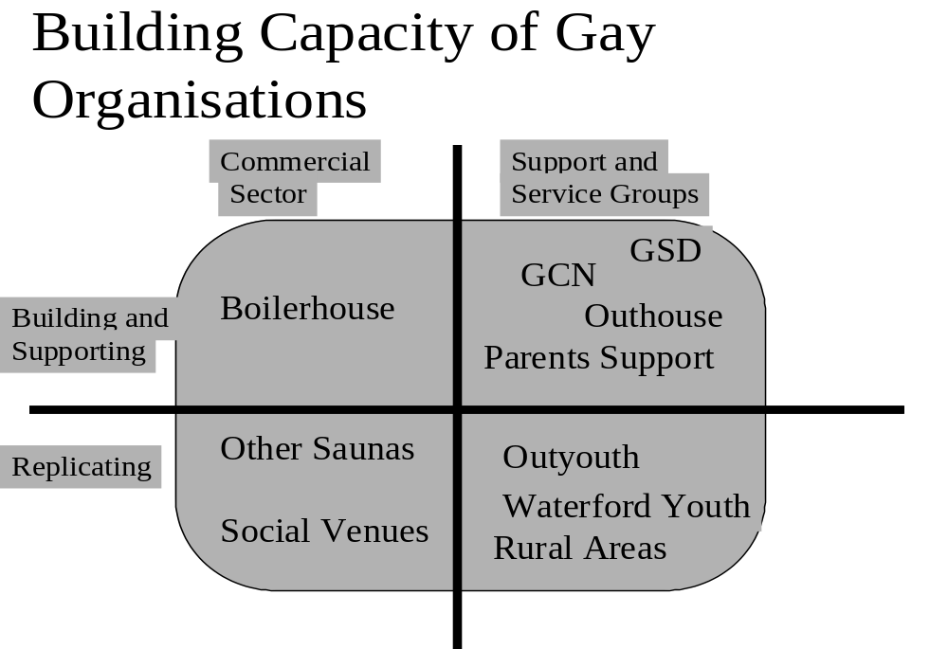

The programme should devote an equal amount of time and energy to the gay commercial sector as to the gay community/voluntary sector.

Commercial Sector
Commitments and involvement initiated with the saunas are unprecedented; and the GHS programme should continue to support this work (that is continuing to develop and review the strategy; and continuing to maintain and build links with service providers) while it is still very much at an experimental stage. An equal amount of commitment should be made, however, to transferring the process and the learning experience to other venues within the gay commercial sector. This includes other saunas, but also social venues - where more imaginative methods of instilling an autonomous capacity for safer sex promotion will be required.

Voluntary Gay Support and Service Groups
In a similar way, the next phase of the programme should continue to allow for support to projects that are still in the process of implementing innovative projects as a result of their participation in phase 1 (examples of these groups are given in the chart above). But there should also be a sustained effort to replicate successful experiences and good practice elsewhere. The experience in Waterford, for example, opens the way to initiate similar developments with local area partnerships in other parts of the country. This part of the programme's next phase would also allow for the establishment of specific initiatives in rural areas; and possibly with older gay men (two areas without a specific focus in the first phase)

Enhancing Services and Nurturing Partnerships
The chart below shows how the policy-related and more mainstream service-related dimensions of the programme should be pursued during the next phase of the programme.
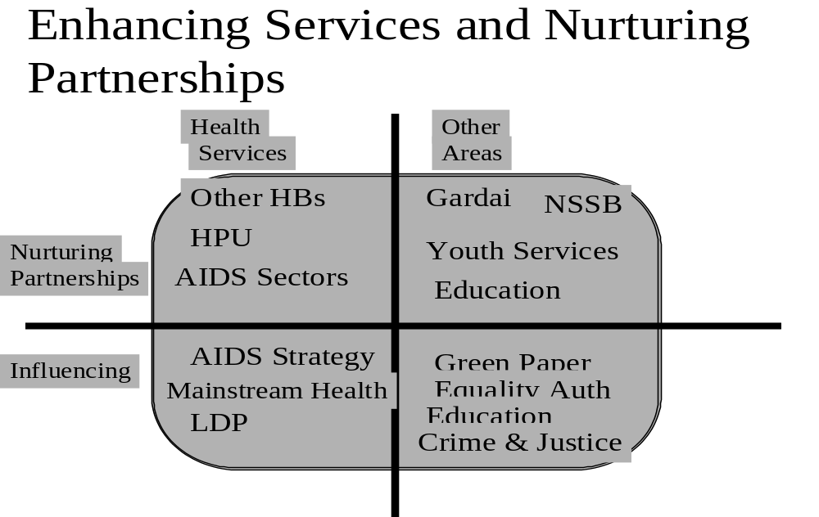

Again, balance will be important: in this case:
- A balance between work within the mainstream health services; and work within related policy and service areas.
- A balance between nurturing and maintaining existing or fledgling partnerships on the one hand; and influencing specific policy developments on the other (which will inevitably lead to the establishment of new partnerships and channels of influence)
As already noted , it will be important to extend the programme's influence to other Health Board areas as part of this strategic arm. It will be also important to maintain ongoing linkages with developments, services and organisations within the wider AIDS strategy framework.

Implications For Organisational Structure
It is recommended that consideration be given to the establishment of dedicated programme development or advisory groups around each of the two programme's main 'arms'. That is:
- An advisory group on gay community capacity-building;
- An advisory group on mainstream service delivery and policy.
This, summarised graphically in the chart below, will allow for the recruitment of additional expertise and experience of direct relevance to programme actions (a need acknowledged by respondents in the evaluation process, including board members themselves). It would also allow for the 'deepening' of partnerships and mutual learning in a very real sense - in that health board workers, social and community workers etc. could become more formally involved in programme implementation in partnership with representatives of gay community organisations. The board can then continue to fulfil a more programme-wide planning and review function, reviewing progress reports from each strategic arm, ensuring balance between then, and interpreting implications for synergy between them.

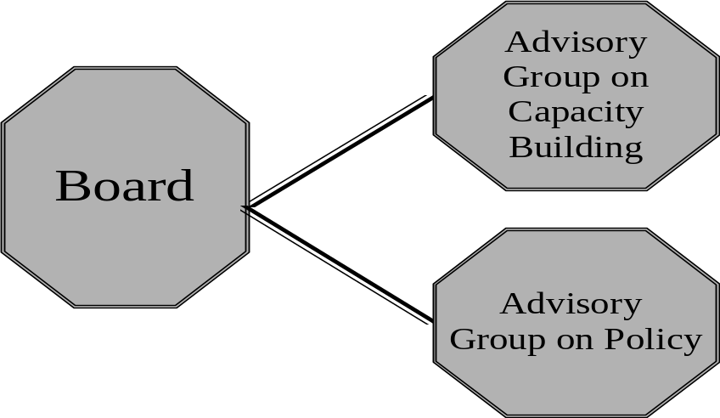

Resource Implications
The model proposed would ensure the maximum possible longer-term impact if:
- A worker was recruited for each of the two strategic development areas proposed. Each should have expertise in the development area in question (ie community development work/capacity building and health/social service policy).
- The programme director was then allowed to act at a higher level strategic level - negotiating with working partners, servicing the board of management, reporting to working partners, overall review etc.
This would obviously require an increase in resources - over and above what was made available for the first phase. There is no doubt, however, given the results of this evaluation, that such a commitment is likely to significantly increase the capacity of the gay community to engage in effective HIV prevention strategies; and to positively impact upon mainstream service delivery across a range of development areas. Furthermore, results also indicate that such a commitment would inevitably lead to the generation of even more resources from the voluntary, statutory and private sectors - both at the Irish and EU level.

Reporting, monitoring and evaluation
- It is strongly recommended that an evaluation element should be incorporated into the programme from an early stage of the next phase. This will allow for baselines to be set, and indicators developed in relation to each of the strategic development areas, as well as specific actions.
- Secondly, a more formal mechanism should be established for programme reporting to the Department of Health and Children. This should include sections of the department relevant to policy development - certainly including the Health Promotion Unit. in this way, maximum benefit from programme lessons and outcomes can be gained at departmental level.

annex 1: Pepers and reports produced by the Gay hiv strategies programme
Gay HIV Strategies (1997-1999) Progress Reports. Dublin.
Gay HIV Strategies (1997). Developing Accessible and Appropriate Services for the Gay Community, Submission to Department of Health and Children Customer Action Plan. Dublin. (Our ref. Gh024).
Gay HIV Strategies (1998). Material Prepared for NSSB Information Pack. Dublin. (Our ref. Gh016a).
Gay HIV Strategies (1998). Submission to Public Library Policy Review Project and An Comhairle Leabharlanna. Dublin. (Our ref. Gh005).
Gay HIV Strategies (1998). The law and Sexual Offences; Submission to Department of Justice, Equality and Law Reform. Dublin. (Our ref. Ghoo5c).
Gay HIV Strategies (1998). Submission to the Department of Social, Community and Family Affairs; Green Paper on the Community and Voluntary Sector. Dublin (Our ref. Ghoo5e).
Gay HIV Strategies (1998). Submission to the working Party on Juvenile Justice. Dublin (Our ref.Ghoo5j).
Gay HIV Strategies (1998). Submission to the Draft Second Report by Ireland under the International Covenant on Economic, Social and Cultural Rights. Dublin (Our ref.Gh005i).
Gay HIV Strategies (1998). Submission to the Combat Poverty Agency Strategic Plan. Dublin (Our ref. Gh030a).
Karl Hayden and Gay HIV Strategies. Working in Partnership for HIV Prevention in Gay Saunas; A Pilot Project in two Gay Saunas. In association with the Eastern Health Board. Dublin (Our ref. Gh012h).
Gay HIV Strategies (1998). Submission to the Department of Justice, Equality and Law Reform on Human Rights Commission. Dublin (Our ref.Gh005f).
Gay HIV Strategies (1999). Submission to the Review of the National AIDS Strategy. Dublin (Our ref. Gh005I).
Gay HIV Strategies (1999). Submission to the Department of Finance on National Development Plan. Dublin (Our ref. Gh005).
Gay HIV Strategies and Gay Health Issues (1999). Paper for Trinity College Dublin Medical Lecture. Dublin (Our ref. Gh028, summary ref. Gh028a).
Gay HIV Strategies (1999). Building Partnerships to Promote Social and Behavioural Change, Summary of Presentation to NASC/HPU Seminar on “Maintaining and Promoting Risk Reduction”. Dublin (Our ref. Gh039a).
Gay HIV Strategies, Nexus Research and Waterford Area Partnership (1999). Local Development Lesbians and Gay Men. Nexus (Our ref. Wd002).
Gay HIV Strategies and Nexus Research (forthcoming). Professional Training for Youth Workers on Gay Youth issues; a Cirriculum Proposal.
GLEN and Nexus Research (1995). Poverty: Lesbians and Gay Men; The Economic and Social Effects of Discrimination. Dublin, Combat Poverty Agency.
Gay Switchboard Dublin and Nexus Research (1998). Outyouth: A Report on the Dublin Lesbian and Gay Youth Group Pilot Project. In association with the Eastern Health Board and Gay HIV Strategies. Nexus (Our ref.Oyfinaldoc).
Parents Support and Gay HIV Strategies(1998). If your Child is Gay or Lesbian. Dublin.
Rose Kieran (1997). HIV Prevention and Gay Youth in Irish Youthwork Scene. National Youth Federation.
Rose Kieran (1998). Parallel Universes: Gay and Lesbian Issues and Local Development. In Community Workers Co – op Local Development in Ireland ; Policy Implications for the Future. Dublin.
Rose Kieran (1998). Mainstreaming Gay Youth and Disadvantage Issues. Summary of a Paper to an European Union Funded (CERIS) Conference on “Identity Risks and AIDS: The Vulnerability of Young Gays in Europe”. Brussels (Our ref.Gh009g).

HIV Prevention Strategies and the Gay Community; GLEN/Nexus Research, 1996 p93
At the time of commencement of the evaluation, the existing Coordinator was resuming his post after a career break, and a new Programme Coordinator was being recruited. It was important at this stage of transition that both were involved in designing the resource audit system.
Shaping a Healthier Future: A Strategy for Effective Healthcare in the 1990s, Department of Health 1994
A Health Promotion Strategy: Making the Healthier Choice the Easier Choice; Department of Health 1995
Parents’ support consists of parents who have a gay or lesbian child, and who provide support for other parents in similar circumstances
Formerly Gay Poz
OutYouth is a social and support group for young people who are, or think they might be, gay, lesbian, bisexual or trans-gendered. It caters for youth between the ages of 17 and 25 and aims to provide ‘a safe and comfortable environment in which young people can come to terms with issues surrounding their sexuality’
Funded and supported by Waterford City Partnership
This consultation and approval process, in line with recommendations made in the HIV Strategies report, resulted in EHB support for five pilot projects. These have been summarised in 3.1.1 above: the Youth Pilot Project with OutYouth and Gay Switchboard; pilot project with Parents’ Support; pilot project with Gay Community News; support for the publication of POZ Ireland; and support for information production and dissemination by the Gay Health Network.
The Programme is run as a partnership between the NYF, the Department of Health and the Department of Education.
The partnership established with the Eastern Health Board was, in itself, one of the most significant outputs of the GHC Programme, discussed in more detail in subsequent Sections.
That is ‘Building Capacity of Gay Organisations’ and ‘Enhancing Mainstream Service Provision’
For example, submissions on Department of Health Customer Actions Plans, National Anti-Poverty Strategy, National Crime Forum.
The intention here was to explore ways in which the EHB could be more formally and ‘visibly’ represented within the Outhouse referral system. Discussions are still ongoing about how this could be best achieved in a mutually beneficial way.
It is highly recommended (discussed in more detail in Section 6) that output and impact indicators are agreed for the next phase of the Programme
New cooperative initiatives with the gay community receive extensive coverage in an issue of the Garda Review (REF)
. For example, this constitutes a major development theme in the current Combat Poverty Agency Strategic Plan - where there is an expressed commitment to ensuring that valuable lessons learned through participative development work at a local level are translated into practical policy initiatives.

